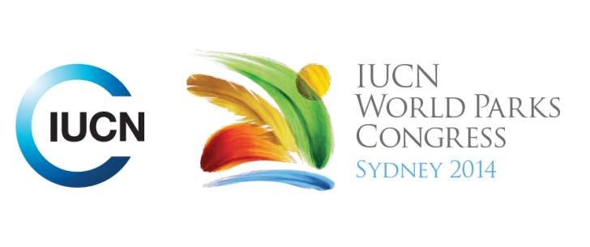

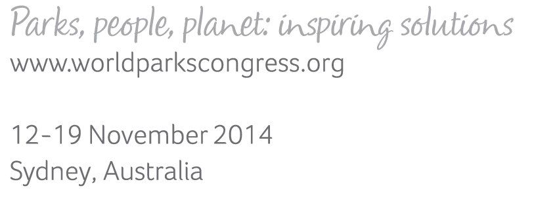

**Please fill-in this word template, save it and email to:**[**WPCReports@iucn.org**](mailto:WPCReports@iucn.org)

|  |  |  |
| --- | --- | --- |
| **Rapporteur’s report on session** | | |
| **Stream Number/WLD/Plenary:--- Social---** | | |
| **Repporteur’s name: --- Jeff Thomas---** | | |
| **Session ID:---907---** | | **Session Name: --- A New Social Compact for Effective and Just Conservation: Opening Plenary---** |
| ***Summarize the session: Capture 1-3 main insights and findings of this session (including promising opportunities and inspiring solutions).*** | | |
| 1. **---** | Youth are discontented with the present situation of how institutions are functioning which have led to greater inequality, poverty, biodiversity loss and unstable climate. They are not despairing however but are optimistic and willing to work together to resolve problems. Too much time is spent on talking and measuring and not enough on action. We need to rely less on models and what we observe with our own eyes.**---** | |
| 2. **---** | We have become disconnected from nature and each other and need a new social compact to reconfigure our relationships with each other and nature. This new social compact is a process and needs to be integrated into decision making across all areas. Women, indigenous groups and youth have all been ignored too long and all need to have their voice and be represented in a diversity of leadership. Collaborative relationships will only work if they are based on trust, humility and respect. We have to reaffirm the beauty of relationships, friendships and ceremonies and make this so powerful it can’t be resisted.**---** | |
| 3. **---** | There is a young people pact which is a collective interested in conservation. They are committed to acting within and outside the boundaries of conservation areas, support emerging leadership, connecting children to nature, be active to conservation threats, healing people and the earth, moving to a conservation economy and reaching out to others and asking for help and giving help to others**---** | |

|  |  |  |
| --- | --- | --- |
| Related keywords | | |
| ---New Social Compact--- | ---Respecting Indigenous and Traditional Knowledge and Culture--- | ---Reaching Conservation Goals--- |

| **Cross Cutting Themes** |
| --- |
| ***If the session was related to a Cross Cutting Theme, please give some information on what has been discussed.*** |
| **---**Click here to enter text.**---** |

|  |
| --- |
| Related cross cutting theme |
| ---Choose an item.--- |

| **Recommendations to the IUCN World Parks Congress** | | | |
| --- | --- | --- | --- |
| ***Capture any specific recommendation from this session for the Innovative Approaches documents / Promise of Sydney (along the line of policy changes, capacity development, financing, practice…)*** | | | |
|  | **It was recommended that:** | **Actors** | **Timeline** |
| 1. **---** | The new social compact be included in developing and reaching stream goals.**---** | **---**Click here to enter text.**---** | **---**Click here to enter text.**---** |
| 2. **---** | Click here to enter text.**---** | **---**Click here to enter text.**---** | **---**Click here to enter text.**---** |
| 3. **---** | Click here to enter text.**---** | **---**Click here to enter text.**---** | **---**Click here to enter text.**---** |

|  |  |  |
| --- | --- | --- |
| Related keywords | | |
| ---Choose an item.--- | ---Choose an item.--- | ---Choose an item.--- |

| **Information for the Communications - Team** |
| --- |
| ***Note any announcements/commitments or people/items of interests to media/communications. Please ensure to include any relevant contact information.*** |
| **---There will be an open forum dialogue at 2pm on the 16th where this discussion will be broadened and further developed.---** |