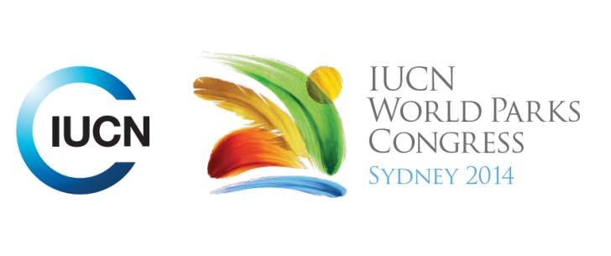

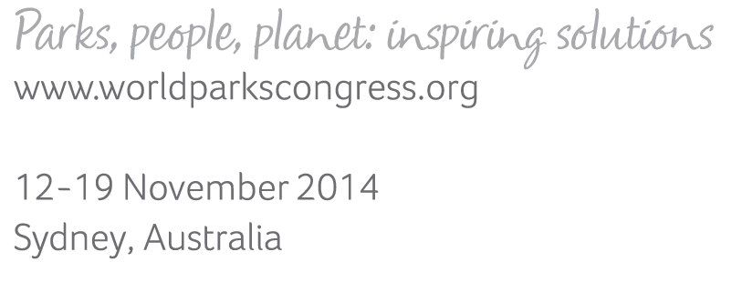

**Please fill-in this word template, save it and email to:**[**WPCReports@iucn.org**](mailto:WPCReports@iucn.org)

|  |  |  |
| --- | --- | --- |
| **Rapporteur’s report on session** | | |
| **Stream Number/WLD/Plenary:--- 8---** | | |
| **Repporteur’s name: --- Nicola Bryden---** | | |
| **Session ID:---573---** | | **Session Name: --- From Awareness to Love: connecting new audiences with parks and protected areas---** |
| ***Summarize the session: Capture 1-3 main insights and findings of this session (including promising opportunities and inspiring solutions).*** | | |
| 1. **---** | With urbanisation, there is a need for more urban nature refuges for wildlife but also to provide opportunities for young people and newcomers to connect with wildlife and nature. Young adult program where urban dwellers shown how to camp safely but demonstrated in an urban park setting. Concerts in parks (by headphone). Swim with the salmon (helping to tag salmon when swimming upstream). Partnership with Google to get streetview footage of remote areas to bring them into urban dwellers’ lives. Hiring young people to engage their peers. Summer jobs are transformative – ‘graduates’ now seek nature out more than ever. **---** | |
| 2. **---** | Getting artists and local young people to engage their passion and respond creatively to a protected area can lead to social media coverage equivalent to advertising for your park worth millions of dollars and transforms relationship between communities and parks. Examples from: Peru (Bahuaja Sonere National Park project) where artists, chefs, photographers, musicians spent time there and then created material in response with international audiences; Ningaloo Coast World Heritage Area with video of interviews explaining what they value at the World Heritage Area and how want it protected for future generations, as well as underwater photography of school children in outfits they have designed using recycled materials, empowering them and giving them confidence and pride in their place, the World Heritage Area. **---** | |
| 3. **---** | Even with increasing protected area coverage and resourcing by parks agencies, there can still be declining visitation, which indicates a loss of connection. When it seems easier to go to Cuba than get outdoors in a National Park in your country, then you know you need listen to young / new audiences and innovate – what are the barriers (keen to get out but scared), reach out, partner with all sorts of groups and engage with technology and other ways of reaching out. Ideas for making parks more user-friendly include: refreshing mascots, school aged programs and competitions using technology, partnering with airlines to get kids out to parks, giant floor maps for hands-on interactivity, equipped campsites (tent pad, verandah and cover, sleeping bags – just bring food), use of GPS and other hand held technology to interpret, learn to camp app (responding to hunger for knowledge), programs in urban parks and historic sites, museums, etc. Only park managers see boundaries, the people are tenure blind. **---** | |

|  |  |  |
| --- | --- | --- |
| Related keywords | | |
| ---Inspiring a New Generation--- | ---World Heritage--- | ---Capacity Development--- |

| **Cross Cutting Themes** |
| --- |
| ***If the session was related to a Cross Cutting Theme, please give some information on what has been discussed.*** |
| **---**Case study of best practice World Heritage emblem use in Gunung Mulu NP – consistent, prominent and repeated use of World Heritage title and emblem and OUV, plus good experience including high standards of presentation of facilities leaves visitors caring about the place and helps extend appreciation to other World Heritage sites. Another case study focused on Ningaloo World Heritage Area engaging young people in creative ways to ensure pride in their place and confidence in themselves. **---** |

|  |
| --- |
| Related cross cutting theme |
| ---World Heritage--- |

| **Recommendations to the IUCN World Parks Congress** | | | |
| --- | --- | --- | --- |
| ***Capture any specific recommendation from this session for the Innovative Approaches documents / Promise of Sydney (along the line of policy changes, capacity development, financing, practice…)*** | | | |
|  | **It was recommended that:** | **Actors** | **Timeline** |
| 1. **---** | Connect with the heart and with passion, not with facts and figures. Engage in partnerships and cross-fertilisation with artists and other creative people in the community (locally and internationally including via social media). Tell the truth about situations, but don’t leave people depressed – give them a solution to take away or inspire them to find their own solutions with a sense of custodianship. **---** | **---**Park managers**---** | **---**Click here to enter text.**---** |
| 2. **---** | Skill up newcomers (younger generations but also first-time facilitation for others new to that environment who may be experiencing fear or uncertainty around nature / use of parks). Take kids out of school and let kids be a ranger for the day. Have/encourage official and self-appointed youth ambassadors and summer rangers.**---** | **---**Park managers**---** | **---**Click here to enter text.**---** |
| 3. **---** | Make engaging with nature fun but also engage on their terms - allow free play and space for creative uses. Treasure Hunts, music festivals, Wilderquest etc. Partner with others to enhance the experience.**---** | **---**Park managers, parents and educators**---** | **---**Click here to enter text.**---** |

|  |  |  |
| --- | --- | --- |
| Related keywords | | |
| ---Inspiring a New Generation--- | ---World Heritage--- | ---Capacity Development--- |

| **Information for the Communications - Team** |
| --- |
| ***Note any announcements/commitments or people/items of interests to media/communications. Please ensure to include any relevant contact information.*** |
| **---Wilderquest – NSW parks program for kids based on technology. See pavilion in hall 2/dome.  #PARKSLIFE is a Parks Canada program to hire 2 young people each year as youth ambassadors to engage peers – like a summer ranger program – great video: “Dear Canada, we know you’re big, .. to hit the road, to light the fire, to set sail, to see you. One Country. One Summer. One Job. Summer jobs will never be the same.” Contact Ellen Bertrand (Parks Canada)** [**http://www.pc.gc.ca/eng/agen/pja-yap/multimedia.aspx?page=2&videoGUID=db7c8e70-3030-4436-93ba-2ed0cff85a95&videoType=2433A748-3EBE-4B5D-B5DC-540003C13456**](http://www.pc.gc.ca/eng/agen/pja-yap/multimedia.aspx?page=2&videoGUID=db7c8e70-3030-4436-93ba-2ed0cff85a95&videoType=2433A748-3EBE-4B5D-B5DC-540003C13456) **Quietest Concert Ever (partnered with public broadcaster) – rock concert in Banff National Park but via headphones. Ellen Bertrand – Parks Canada Program to send southern students to north for the summer (Students on Ice) leads to transformative experiences – Ellen Bertrand – Parks Canada. Video shown: Ningaloo World Heritage Area – young people interviewed about the WHA and why/how it should be protected. Contact Penny Spoelder TRC Tourism (Australia).** [**http://vimeo.com/93685112**](http://vimeo.com/93685112) **---** |