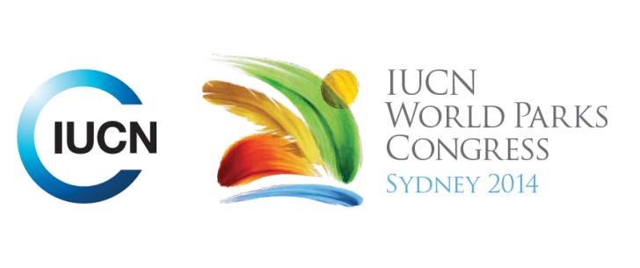

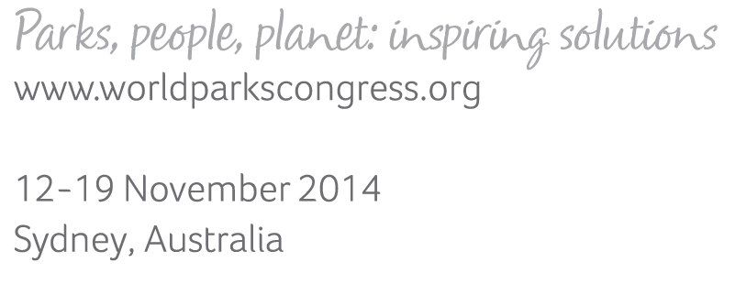

**Please fill-in this word template, save it and email to:**[**WPCReports@iucn.org**](mailto:WPCReports@iucn.org)

|  |  |  |
| --- | --- | --- |
| **Rapporteur’s report on session** | | |
| **Stream Number/WLD/Plenary:--- 8---** | | |
| **Repporteur’s name: --- Eri Leong---** | | |
| **Session ID:---548---** | | **Session Name: --- Where to from here? Our commitments to action---** |
| ***Summarize the session: Capture 1-3 main insights and findings of this session (including promising opportunities and inspiring solutions).*** | | |
| 1. **---** | This session presented the Young People’s Pact and Interleadership Framework to the World Parks Congress. They will be available online. As well as formally presenting the pact, key messages were communicated through music and song. Everyone in the room was invited to make and share one commitment to action for inspiring the new generation. **---** | |
| 2. **---** | Examples of organisational/institutional commitments included: The US Parks Service will provide a “ticket to ride” (free transport access to national parks) for young people. The Brandwein Institute will host a Inspiring a New Generation North American Summit in November 2015. Parks Canada will establish a Youth Council to meet with the Executive every 8 weeks to strategically inspire a new generation, and the Head will work with heads of parks institutions worldwide for a global strategy to connect youth to nature. Griffith University is planning to develop university courses offering immersive outdoor study. **---** | |
| 3. **---** | Click here to enter text.**---** | |

|  |  |  |
| --- | --- | --- |
| Related keywords | | |
| ---Choose an item.--- | ---Choose an item.--- | ---Choose an item.--- |

| **Cross Cutting Themes** |
| --- |
| ***If the session was related to a Cross Cutting Theme, please give some information on what has been discussed.*** |
| **---**Click here to enter text.**---** |

|  |
| --- |
| Related cross cutting theme |
| ---Choose an item.--- |

| **Recommendations to the IUCN World Parks Congress** | | | |
| --- | --- | --- | --- |
| ***Capture any specific recommendation from this session for the Innovative Approaches documents / Promise of Sydney (along the line of policy changes, capacity development, financing, practice…)*** | | | |
|  | **It was recommended that:** | **Actors** | **Timeline** |
| 1. **---** | Develop global strategies to set targets and guidelines for connecting youth to nature.**---** | **---**Click here to enter text.**---** | **---**Click here to enter text.**---** |
| 2. **---** | Click here to enter text.**---** | **---**Click here to enter text.**---** | **---**Click here to enter text.**---** |
| 3. **---** | Click here to enter text.**---** | **---**Click here to enter text.**---** | **---**Click here to enter text.**---** |

|  |  |  |
| --- | --- | --- |
| Related keywords | | |
| ---Choose an item.--- | ---Choose an item.--- | ---Choose an item.--- |

| **Information for the Communications - Team** |
| --- |
| ***Note any announcements/commitments or people/items of interests to media/communications. Please ensure to include any relevant contact information.*** |
| **---**Click here to enter text.**---** |