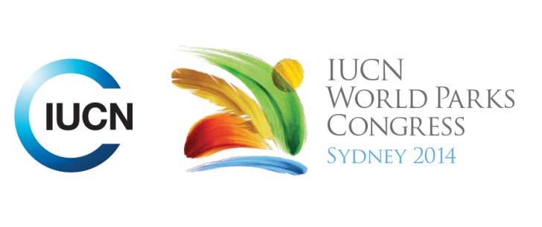



**Please fill-in this word template, save it and email to:**[**WPCReports@iucn.org**](mailto:WPCReports@iucn.org)

|  |  |  |
| --- | --- | --- |
| **Rapporteur’s report on session** | | |
| **Stream Number/WLD/Plenary:--- 7---** | | |
| **Repporteur’s name: --- Gen Pezzimenti---** | | |
| **Session ID:---516---** | | **Session Name: --- Sustainable Harvests: Climate change and regulatory impacts---** |
| ***Summarize the session: Capture 1-3 main insights and findings of this session (including promising opportunities and inspiring solutions).*** | | |
| 1. **---** | Climate change impacts in the Great Barrier Reef Marine Park (National marine protected area and World Heritage Area) are of particular concern to the Indigenous people who are concerned about the impacts such as loss of their totem species (dugong and turtle), reduction of species for harvesting, and the potential displacement of Indigenous people from coastal communities where they cannot access these species for customary purposes. Traditional Use Management Agreements have been adopted in the Great Barrier Reef Marine Park area to recognise the sustainable harvest and management of traditional species which may be endangered such as dugong and turtle, by indigenous peoples. This management tool has been developed in consultation with both Indigenous groups and government agencies, and is viewed as an effective tool by all.**---** | |
| 2. **---** | There are evolving regulatory approaches to harvesting rights for Indigenous and local communities, which has created tension between regulatory responses in protected areas that have a negative and disproportionate impact on Indigenous peoples, and the need to protect endangered species (which often have a cultural significance) which are heavily impacted not by traditional harvests, but by impacts associated with Climate Change. There is greater recognition now that these endangered species are culturally important to Indigenous peoples (species such as dugong and turtle in Northern Australia) are part of Indigenous stories of creation, songlines, and sites; and constitute the very fabric of first nations, and thus the will of indigenous people is not to hunt them to extinction. This has been a long-held western perception of traditional hunting. On the contrary, Indigenous people are best able to manage these resources sustainably because of this deep cultural connection. Western management arrangements are beginning to reflect this understanding: higher penalties for the take of traditional species have been dismissed in some cases, and agreements between Indigenous peoples and governments are being established to recognize traditional use of resources. In this way policy makers and the community are connecting. **---** | |
| 3. **---** | Traditional knowledge, which is a knowledge framework that reflects a deep and long understanding of the dynamics of nature and human and cultural interactions with nature, has an integral role in the environment sphere and in particular management of endangered species that are culturally important. Consideration or integration of this knowledge in policy and planning and management strategies would result in improved management of endangered species that are valued both by Indigenous peoples and by western frameworks of ecological recognition, such as the Convention of Biological Diversity and the World Heritage Convention. Traditional and cultural concepts such as tabu, seasons, and signs from nature of immediate and long-term environmental change, may enhance or be considered equal to scientific knowledge frameworks in the area of sustainable harvest of traditional resources. The knowledge of how to sustainably manage species that are traditionally important is also embedded in the language of traditional people.**---** | |

|  |  |  |
| --- | --- | --- |
| Related keywords | | |
| ---World Heritage--- | ---Respecting Indigenous and Traditional Knowledge and Culture--- | ---Responding to Climate Change--- |

| **Cross Cutting Themes** |
| --- |
| ***If the session was related to a Cross Cutting Theme, please give some information on what has been discussed.*** |
| **---**Traditional knowledge and customary laws could hold the key to effective climate change adaptation strategies that could be incorporated in the legal framework. Ideas and inspiration about how to effectively adapt to climate change can be learnt from other nations such as New Zealand (in the area of coastal protection).**---** |

|  |
| --- |
| Related cross cutting theme |
| ---Capacity Development--- |

| **Recommendations to the IUCN World Parks Congress** | | | |
| --- | --- | --- | --- |
| ***Capture any specific recommendation from this session for the Innovative Approaches documents / Promise of Sydney (along the line of policy changes, capacity development, financing, practice…)*** | | | |
|  | **It was recommended that:** | **Actors** | **Timeline** |
| 1. **---** | The impacts of extreme weather events which will increase in frequency and intensity with climate change and will have disastrous impacts, particularly for indigenous peoples, be articulated and emphasised. The impacts of these extreme weather events have not been sufficiently articulated and emphasised in the past.**---** | **---**Click here to enter text.**---** | **---**Click here to enter text.**---** |
| 2. **---** | Traditional knowledge is recognised as a valid knowledge framework in the environmental sphere, specifically in policy and planning, and is incorporated, so that it may be considered a mainstream knowledge system, as western knowledge is considered. Customary laws should also be considered in legislation and policy for the improved sustainable management of traditional species, and should be a source of inspiration for adaptation strategies to climate change impacts .**---** | **---**Click here to enter text.**---** | **---**Click here to enter text.**---** |
| 3. **---** | Rather than trying to fit Intellectually property rights or the concept of traditional knowledge into the Australian Native Title Act which focuses on land rather than knowledge, a new species of common law recognition could be formed that recognises knowledge**---** | **---**Click here to enter text.**---** | **---**Click here to enter text.**---** |

|  |  |  |
| --- | --- | --- |
| Related keywords | | |
| ---Enhancing Diversity and Quality of Governance--- | ---Respecting Indigenous and Traditional Knowledge and Culture--- | ---Responding to Climate Change--- |

| **Information for the Communications - Team** |
| --- |
| ***Note any announcements/commitments or people/items of interests to media/communications. Please ensure to include any relevant contact information.*** |
| **---Ruci Mafi Botei, in reference to the voyage of the Vaka canoes from the Pacific Islands: *It is not just a voyage of culture. The ocean is us. We are the ocean*.---** |