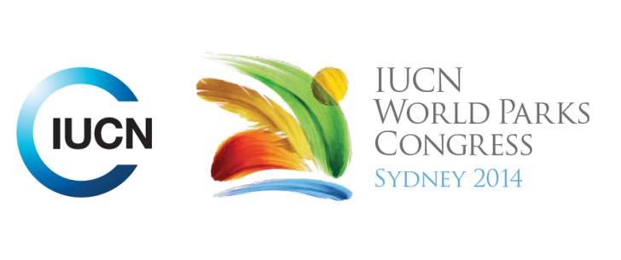



**Please fill-in this word template, save it and email to:**[**WPCReports@iucn.org**](mailto:WPCReports@iucn.org)

|  |  |  |
| --- | --- | --- |
| **Rapporteur’s report on session** | | |
| **Stream Number/WLD/Plenary:--- Stream 5---** | | |
| **Repporteur’s name: --- Moumini Savadogo---** | | |
| **Session ID:---444---** | | **Session Name: --- Integrating Protected areas into plans and policies (part 1)---** |
| ***Summarize the session: Capture 1-3 main insights and findings of this session (including promising opportunities and inspiring solutions).*** | | |
| 1. **---** | The process of revising the NBSAPs taking into account the Aichi targets is a promising opportunity for the integration of PA into sustainable development and reconciles conservation and development. Broadly all planning processes related to PA must take into account these targets. We have to adopt a new conservation paradigm, which is to manage PA for Biodiversity and development while respecting and responding to what nature need. Examples from Myanmar (NBSAP) Iran (establishment of a Biosphere transboundary reserve) and National PA expansion strategy for South Africa and Australia are illustrative of such process. However it is should be noted again that good governance and holistic approach/institutional frameworks are prerequisite for effective integration of biodiversity/PA into national development plans and policies. We must not overlook the impacts of the development threats on biodiversity and PA**---** | |
| 2. **---** | Importance for conservation community to communicate positively on the contribution as well as the opportunities related to protected areas. This communication must be based on the decision making language and on evidence-based. Therefore we need to understand the development decision making processes, internalise the costs of environmental externalities as to relate it to the basic priorities of communities or development goals (food security, resilience, education jobs, livelihoods, water security, economic growth, etc.). Some reconciling solutions which have been highlighted by participants include development Landscape planning that permits PA and production Wins, Carrot and stick incentives for PA management improves service delivery, Sufficient valuation of PA with sustainable financing pays the costs of protection (ex of Sink tax)**---** | |
| 3. **---** | The success of the integration of P into development planning relies strongly on the participatory approach. We must ensure proper use of bottom-up approach which promotes inclusive stakeholders participation, especially local communities in all the phases of the planning and decision making **---** | |

|  |  |  |
| --- | --- | --- |
| Related keywords | | |
| ---Reconciling Development Challenges--- | ---Reaching Conservation Goals--- | ---Supporting Human Life--- |

| **Cross Cutting Themes** |
| --- |
| ***If the session was related to a Cross Cutting Theme, please give some information on what has been discussed.*** |
| **---**There is a need to shape the understanding as well as the operational capacities of the countries for effective integration of PA into sustainable development planning**---** |

|  |
| --- |
| Related cross cutting theme |
| ---Capacity Development--- |

| **Recommendations to the IUCN World Parks Congress** | | | |
| --- | --- | --- | --- |
| ***Capture any specific recommendation from this session for the Innovative Approaches documents / Promise of Sydney (along the line of policy changes, capacity development, financing, practice…)*** | | | |
|  | **It was recommended that:** | **Actors** | **Timeline** |
| 1. **---** | None**---** | **---**Click here to enter text.**---** | **---**Click here to enter text.**---** |
| 2. **---** | Click here to enter text.**---** | **---**Click here to enter text.**---** | **---**Click here to enter text.**---** |
| 3. **---** | Click here to enter text.**---** | **---**Click here to enter text.**---** | **---**Click here to enter text.**---** |

|  |  |  |
| --- | --- | --- |
| Related keywords | | |
| ---Choose an item.--- | ---Choose an item.--- | ---Choose an item.--- |

| **Information for the Communications - Team** |
| --- |
| ***Note any announcements/commitments or people/items of interests to media/communications. Please ensure to include any relevant contact information.*** |
| **---**Click here to enter text.**---** |