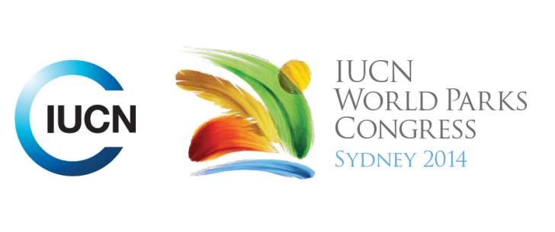

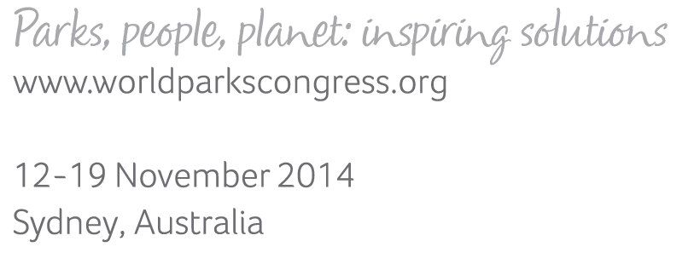

**Please fill-in this word template, save it and email to:**[**WPCReports@iucn.org**](mailto:WPCReports@iucn.org)

|  |  |  |
| --- | --- | --- |
| **Rapporteur’s report on session** | | |
| **Stream Number/WLD/Plenary:--- 5---** | | |
| **Repporteur’s name: --- David Andrew---** | | |
| **Session ID:---436---** | | **Session Name: --- Ecological safeguards for equitable, sustainable development & inclusive decisions (Part 1). ---** |
| ***Summarize the session: Capture 1-3 main insights and findings of this session (including promising opportunities and inspiring solutions).*** | | |
| 1. **---** | Environmental Impact Assessments (EIAs) are the primary tool for avoiding or mitigating impacts of development. This session was basically a series of case studies of how various Environmental Impact Assessment methods worked. Examples included guidelines for the International Finance Corporation (IFC) of the World Bank, particularly Performance Standard 6 (PF6) – Biodiversity Conservation and Sustainability Management of Living Natural Resources; strategic impact assessments on a large scale, e.g. the Great Barrier Reef; offset banks, e.g. a coral-growing scheme in Hawaii. The chief message to emerge was that EIAs won’t please everyone but it takes a multi-sectoral community to achieve the best result. (Because the session started late owing to technical difficulties there was no time for discussion afterwards) **---** | |
| 2. **---** | Click here to enter text.**---** | |
| 3. **---** | Click here to enter text.**---** | |

|  |  |  |
| --- | --- | --- |
| Related keywords | | |
| ---Reconciling Development Challenges--- | ---Marine--- | ---Enhancing Diversity and Quality of Governance--- |

| **Cross Cutting Themes** |
| --- |
| ***If the session was related to a Cross Cutting Theme, please give some information on what has been discussed.*** |
| **---**Click here to enter text.**---** |

|  |
| --- |
| Related cross cutting theme |
| ---Choose an item.--- |

| **Recommendations to the IUCN World Parks Congress** | | | |
| --- | --- | --- | --- |
| ***Capture any specific recommendation from this session for the Innovative Approaches documents / Promise of Sydney (along the line of policy changes, capacity development, financing, practice…)*** | | | |
|  | **It was recommended that:** | **Actors** | **Timeline** |
| 1. **---** | Click here to enter text.**---** | **---**Click here to enter text.**---** | **---**Click here to enter text.**---** |
| 2. **---** | Click here to enter text.**---** | **---**Click here to enter text.**---** | **---**Click here to enter text.**---** |
| 3. **---** | Click here to enter text.**---** | **---**Click here to enter text.**---** | **---**Click here to enter text.**---** |

|  |  |  |
| --- | --- | --- |
| Related keywords | | |
| ---Choose an item.--- | ---Choose an item.--- | ---Choose an item.--- |

| **Information for the Communications - Team** |
| --- |
| ***Note any announcements/commitments or people/items of interests to media/communications. Please ensure to include any relevant contact information.*** |
| **---**Click here to enter text.**---** |