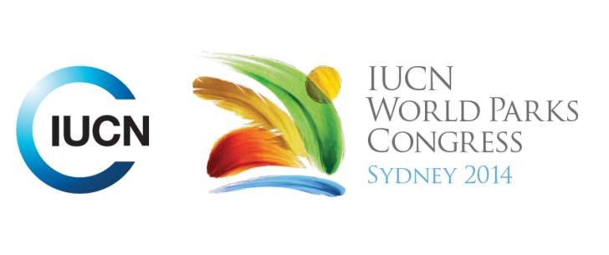

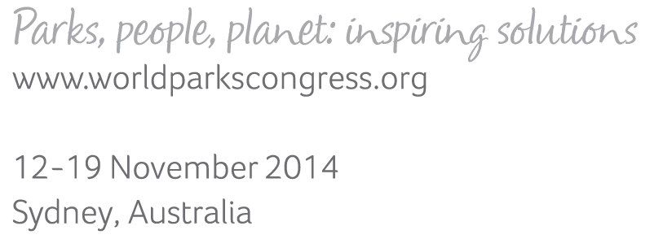

**Please fill-in this word template, save it and email to:**[**WPCReports@iucn.org**](mailto:WPCReports@iucn.org)

|  |  |  |
| --- | --- | --- |
| **Rapporteur’s report on session** | | |
| **Stream Number/WLD/Plenary:--- 5---** | | |
| **Repporteur’s name: ---** Click here to enter text.**---** | | |
| **Session ID:---433---** | | **Session Name: ---** They're not making it any more: Integrating protected areas into spatial planning**---** |
| ***Summarize the session: Capture 1-3 main insights and findings of this session (including promising opportunities and inspiring solutions).*** | | |
| 1. **---** | This session continued the discussion of the previous session, about how to manage expectations about the landscape and competing land uses, due to expectations for multiple outcomes including biodiversity, food production, etc from the same spatial units. The session focused on how to manage these trade-offs, by considering some examples focused on spatial planning and how PAs can be integrated within spatial planning processes. Again, this supports a more systemic approach to managing landscapes and PAs within those landscapes. The session discussed transnational efforts, such as the East Asian Australasian flyway, which emphasised the need for engagement across multiple agencies, international diplomacy, and increasing understanding of the value of tidal wetland habitats, to support international connectivity for migratory birds. It also discussed national efforts such as Thailand’s approach to develop a national system plan for PAs that focuses on connectivity – ecological, social and economic. **---** | |
| 2. **---** | An inspiring solution is provided by the EU’s Natura 2000 network of protected areas demonstrating integrating PAs within the landscape. Given Europe’s long history of development and land use this network recognises the need to integrate PAs into the landscape, going beyond political boundaries and short term political decision-making. Many of the sites are privately owned and there is a collaborative approach to working with land owners and managing uses. It ensures unnecessarily damaging development doesn't go ahead, due to presence of EU directives/laws. Natura 2000 is also being integrated into EU sectoral plans and policies, for example for the agriculture sector, so it is having a broader impact. The network is also at the core of the broader EU Green Infrastructure concept, which is aimed at supporting natural capital in Europe, by a strategically planned and developed network of natural and semi-natural areas that support ecosystem services. It also supports connectivity. It also uses accessible spatial planning tools (map viewer based on google) to ensure information is easily accessible. [keyword – governance, supporting human life] **---** | |
| 3. **---** | The session also emphasised the importance of integrating marine spatial planning with marine protected areas. Marine spatial planning (MSP) can promote ‘blue growth,’ but this needs to rest on a foundation of conservation. Priority areas for conservation must be identified through MSP, to provide critical habitat, support areas where there are high concentrations of ecosystem services, are culturally or spiritually valued, maintain production and are expected to be resilient in the future. Conversely, effective MPAs also require inclusion in broader MSP – ‘islands of protection in a sea of degradation’ won’t work. This is very important in the marine context, where boundaries are fluid and impacts move about. Thus, for MPAs to succeed they must support marine spatial planning and sustained use, and for marine spatial planning to help maintain MPAs, those MPAs must be well-placed and well-managed. There needs to be a bridging between MPA and MSP communities to work collaboratively for positive outcomes. One inspiring example is a project in Gyaros, Greece which is a biodiversity hotspot in the Mediterranean with considerable history. While an MPA project, it is also broader than this, applying an integrated approach that will use marine spatial planning to regulate activities, based on scientific evidence, with strong engagement of a range of stakeholders including national and regional government, NGOs, research and academics, and local communities groups. It will adopt a co-management approach to drive the process and resolve conflicts, and decide on trade-offs to balance conservation (reefs, monk seals) and development (sustainable fishing, tourism). [keyword – governance; supporting human life] **---** | |

|  |  |  |
| --- | --- | --- |
| Related keywords | | |
| ---Choose an item.--- | ---Choose an item.--- | ---Choose an item.--- |

| **Cross Cutting Themes** |
| --- |
| ***If the session was related to a Cross Cutting Theme, please give some information on what has been discussed.*** |
| **---**The session included a particular emphasis on marine spatial planning and MPAs, including a case study of integrated marine planning for a project in the Mediterranean, in Greece. See section above. [cross-cutting – marine] **---** |

|  |
| --- |
| Related cross cutting theme |
| ---Choose an item.--- |

| **Recommendations to the IUCN World Parks Congress** | | | |
| --- | --- | --- | --- |
| ***Capture any specific recommendation from this session for the Innovative Approaches documents / Promise of Sydney (along the line of policy changes, capacity development, financing, practice…)*** | | | |
|  | **It was recommended that:** | **Actors** | **Timeline** |
| 1. **---** | MPA planners need to insert themselves in marine spatial planning processes, and both need to work together collaboratively for positive outcomes.**---** | **---**MPA planners, marine spatial planners**---** | **---**Click here to enter text.**---** |
| 2. **---** | Click here to enter text.**---** | **---**Click here to enter text.**---** | **---**Click here to enter text.**---** |
| 3. **---** | Click here to enter text.**---** | **---**Click here to enter text.**---** | **---**Click here to enter text.**---** |

|  |  |  |
| --- | --- | --- |
| Related keywords | | |
| ---Choose an item.--- | ---Choose an item.--- | ---Choose an item.--- |

| **Information for the Communications - Team** |
| --- |
| ***Note any announcements/commitments or people/items of interests to media/communications. Please ensure to include any relevant contact information.*** |
| **---**Click here to enter text.**---** |