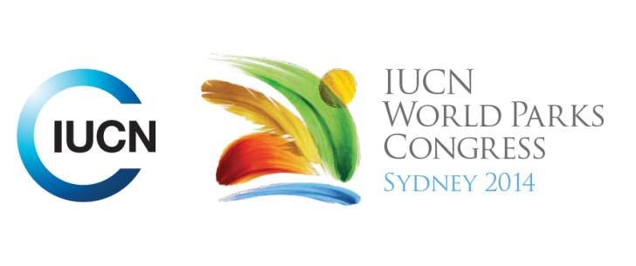



**Please fill-in this word template, save it and email to:**[**WPCReports@iucn.org**](mailto:WPCReports@iucn.org)

|  |  |  |
| --- | --- | --- |
| **Rapporteur’s report on session** | | |
| **Stream Number/WLD/Plenary:--- Stream 4---** | | |
| **Repporteur’s name: --- Anshuman Saikia---** | | |
| **Session ID:---403---** | | **Session Name: --- Financing protected areas through payments for environmental services (PES): A possibility?---** |
| ***Summarize the session: Capture 1-3 main insights and findings of this session (including promising opportunities and inspiring solutions).*** | | |
| 1. **---** | A key insight from the Session was that in order to further Sustainable Financing Mechanisms including Payments for Ecosystem Services (PES) for Protected Areas it is important to not just have enabling policy environment but also clearly identified institutional arrangements that include identification of the roles of the buyers as well as the communities that benefit from these services. In this context, the communities need to have clear payment benefits that are standardised as variable benefits as in the case of Vietnam's Payment for Forest Ecosystem Services is likely to lead to conflicts. The lesson from Vietnam is also that PES can be successful only when beneficiaries are clearly identified and the concerned landscape is not fragmented as the corresponding payments would vary for individuals given there will be variation in the ecosystem service values **---** | |
| 2. **---** | The sustainable financing mechanisms including PES schemes can be successful if there are certain economies of scale as otherwise the benefits will be localised and more in the form of eco-tourism related benefits for local communities as was evident from Bangladesh. However, on a larger scale these are found to be more effective as the economies of scale in terms of the market for ecosystem services is viable. It was also found that there are complexities in dealing with multiple ecosystem service benefits as opposed to PES benefits related to hydropower or ecotourism in Vietnam. The Bolsa Verde is an example of national level cash transfer schemes which have co-benefits of reducing poverty while addressing forest degradation and promoting sustainable production. **---** | |
| 3. **---** | The third insight is for sustainable financing mechanisms to be successful it is important to establish the new and innovative institutional mechanisms at multiple levels as required ranging from the ecosystem level to the national level or build on institutional mechanisms of existing initiatives. This was evident from the example in Indonesia of the establishment of the National Trust Fund for Marine Conservation which is in the process of addressing the USD 17.5 million funding gap for MPAs in the country given the budget available with government is only USD 7.5 million while the resources required are USD 22.5 million. The EU led Life-Making Good Natura (MGN) project is an example of a PES initiative building upon an existing large initiative, Natura 2000 and also leveraging its institutional mechanisms and frameworks **---** | |

|  |  |  |
| --- | --- | --- |
| Related keywords | | |
| ---Supporting Human Life--- | ---Reconciling Development Challenges--- | ---Choose an item.--- |

| **Cross Cutting Themes** |
| --- |
| ***If the session was related to a Cross Cutting Theme, please give some information on what has been discussed.*** |
| **---**The Indonesia presentation focused on sustainable financing for marine protected areas in the country**---** |

|  |
| --- |
| Related cross cutting theme |
| ---Marine--- |

| **Recommendations to the IUCN World Parks Congress** | | | |
| --- | --- | --- | --- |
| ***Capture any specific recommendation from this session for the Innovative Approaches documents / Promise of Sydney (along the line of policy changes, capacity development, financing, practice…)*** | | | |
|  | **It was recommended that:** | **Actors** | **Timeline** |
| 1. **---** | It is recommended that the World Parks Congress actively considers including sustainable financing mechanisms including tools such as PES building on experience from countries in Asia and Latin America **---** | **---**FAO, IUCN, CI**---** | **---**Click here to enter text.**---** |
| 2. **---** | Click here to enter text.**---** | **---**Click here to enter text.**---** | **---**Click here to enter text.**---** |
| 3. **---** | Click here to enter text.**---** | **---**Click here to enter text.**---** | **---**Click here to enter text.**---** |

|  |  |  |
| --- | --- | --- |
| Related keywords | | |
| ---Supporting Human Life--- | ---Reconciling Development Challenges--- | ---Choose an item.--- |

| **Information for the Communications - Team** |
| --- |
| ***Note any announcements/commitments or people/items of interests to media/communications. Please ensure to include any relevant contact information.*** |
| **---**Click here to enter text.**---** |