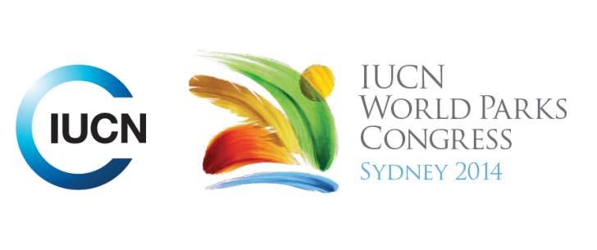



**Please fill-in this word template, save it and email to:**[**WPCReports@iucn.org**](mailto:WPCReports@iucn.org)

|  |  |  |
| --- | --- | --- |
| **Rapporteur’s report on session** | | |
| **Stream Number/WLD/Plenary:--- Stream 4---** | | |
| **Repporteur’s name: --- Rachel Miller---** | | |
| **Session ID:---382---** | | **Session Name: --- Opportunities and challenges to produce food in protected areas.---** |
| ***Summarize the session: Capture 1-3 main insights and findings of this session (including inspiring stories, promising opportunities and innovative solutions).*** | | |
| 1. **---** | Wild collection of resources plays a very important role in food security. 43% of globally certified organic industry is collected from the wild, often by local/indigenous communities. Need to respect indigenous communities/knowledge and not lock them out of PAs, because they have always used the forests and are part of the ecological processes. Need for community ownership and involvement in management plans. Wild collection empowers women in particular because they make up the majority of gatherers. Organic International work to certify local wild collection industries, use indigenous/local and scientific knowledge to ensure sustainable harvesting and create a market for products to get the premium price for local communities. Important to create a face/story behind the product to market it, then people are willing to pay more – value adding. Examples include honey collection and herbal cosmetic industry in India. Also important to create marketing avenues and infrastructure for local communities to get to markets. Good govt policy is essential to help access to these markets. **---** | |
| 2. **---** | Conflict between traditional authorities with new legal structure of PAs. Tenure, access, governance. In South Africa there has been an in balance between traditional leaders and newly formed legislated government trusts in regard to Reserves handed back to black communities, in relationship to resources and how benefits/money are distributed. There is a perception that the traditional leaders don’t know how to manage the resource that’s why the trusts are formed **---** | |
| 3. **---** | The idea that allowing communities to use the resources of protected areas can actually increase conservation outcomes. This can be the case on the perimeter of PAs and also within PAs. Allowing local communities to use resources on the edge of PAs can make them value the PAs and in turn protects the biodiversity within them. In Italy all PAs have agriculture and people living within them – agriculture is part of the PAs natural landscape. Challenge has been to keep farmers in these areas and create opportunities for them – marketing of products with WWF to supermarkets, linking quality of products to the territory/PA it comes from. **---** | |

|  |  |  |
| --- | --- | --- |
| Related keywords | | |
| ---Respecting Indigenous and Traditional Knowledge and Culture--- | ---Capacity Development--- | ---Enhancing Diversity and Quality of Governance--- |

| **Cross Cutting Themes** |
| --- |
| ***If the session was related to a Cross Cutting Theme, please give some information on what has been discussed.*** |
| **---**None**---** |

|  |
| --- |
| Related cross cutting theme |
| ---Choose an item.--- |

| **Recommendations to the IUCN World Parks Congress** | | | |
| --- | --- | --- | --- |
| ***Capture any specific recommendation from this session for the Innovative Approaches documents / Promise of Sydney (along the line of policy changes, capacity development, financing, practice…)*** | | | |
|  | **It was recommended that:** | **Actors** | **Timeline** |
| 1. **---** | Click here to enter text.**---** | **---**Click here to enter text.**---** | **---**Click here to enter text.**---** |
| 2. **---** | Click here to enter text.**---** | **---**Click here to enter text.**---** | **---**Click here to enter text.**---** |
| 3. **---** | Click here to enter text.**---** | **---**Click here to enter text.**---** | **---**Click here to enter text.**---** |

|  |  |  |
| --- | --- | --- |
| Related keywords | | |
| ---Choose an item.--- | ---Choose an item.--- | ---Choose an item.--- |

| **Information for the Communications - Team** |
| --- |
| ***Note any announcements/commitments or people/items of interests to media/communications. Please ensure to include any relevant contact information.*** |
| **------** |