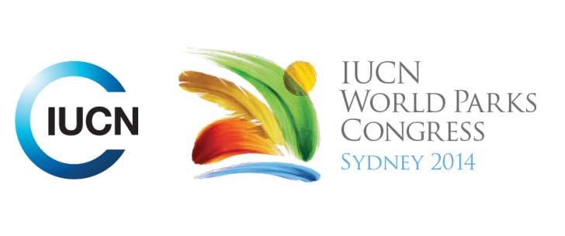

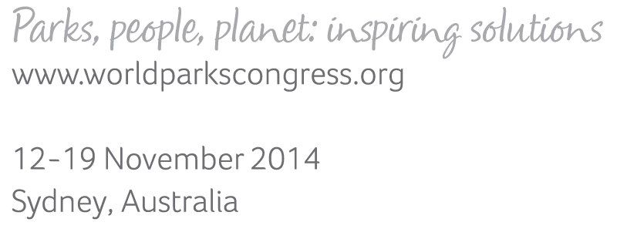

**Please fill-in this word template, save it and email to:**[**WPCReports@iucn.org**](mailto:WPCReports@iucn.org)

|  |  |  |
| --- | --- | --- |
| **Rapporteur’s report on session** | | |
| **Stream Number/WLD/Plenary:--- Stream 4---** | | |
| **Repporteur’s name: --- Anshuman Saikia---** | | |
| **Session ID:---371---** | | **Session Name: --- Nature-based solutions for disasters: lessons from practices on the ground---** |
| ***Summarize the session: Capture 1-3 main insights and findings of this session (including promising opportunities and inspiring solutions).*** | | |
| 1. **---** | A clear insight was on the links between water resources management and disaster risk reduction at multiple levels, ranging from the watershed level to the river basin level especially given 90% of the most fatal disasters between 1900 and 2006 were water related. It was pointed out that the global objectives of integrated water resources management are very much aligned with the HFA priorities and hence they become mutually reinforcing and also common objectives. The IWRM example was of the WANI funded TACA Basin while the watershed specific example was on Yunnan where Shan Shui Conservation is working with communities in restoring watersheds and forest areas for water protection to reduce drought risks. Similarly bioengineering solutions being adopted for ecologically safe roads in Nepal is supporting in protecting the watershed of the Phewa Lake and reducing disaster risk **---** | |
| 2. **---** | Another important finding was the value of Eco-DRR focusing on local and community ownership which makes it a more cost-effective option than grey infrastructure. There are also opportunities that were identified of integrating local and indigenous knowledge systems with modern scientific knowledge as in the case of Nepal and China. It was recognised there is considerable pressure on traditional knowledge systems from modern scientific knowledge hence making it imperative to recognise and promote. The role of local materials and resources such as bamboo in the case of Nepal for reinforcing roads with bioengineering aspects along with structural engineering measures thus blending grey and green infrastructure. In addition, in China traditional species were promoted for forest as they provide more ecosystem services than single mono-species forests. There is also need to recognise the role traditional indigenous knowledge systems such as in the case of the ethnic minorities in China play in ensuring conservation such as their belief in sacred forests **---** | |
| 3. **---** | It is important to have land use plans negotiated and developed together with communities prior to undertaking restoration for reducing risks to natural disasters. The example of Nigeria showed this enabled not just protection of 50% of the rainforest area but also sustainable exploitation of NTFPs in other areas. In addition, a clear mechanism was put in place for equitable benefit sharing. The involvement of communities in developing the land use plans fostered more community ownership as they recognised the social, environmental, economic, aesthetic, spiritual and intrinsic value of protected areas. It was also recognised from the presentations by a few of the presenters that governance arrangements need to be in place to ensure that a few individuals are not able to disturb such systems. **---** | |

|  |  |  |
| --- | --- | --- |
| Related keywords | | |
| ---Supporting Human Life--- | ---Respecting Indigenous and Traditional Knowledge and Culture--- | ---Enhancing Diversity and Quality of Governance--- |

| **Cross Cutting Themes** |
| --- |
| ***If the session was related to a Cross Cutting Theme, please give some information on what has been discussed.*** |
| **---**There was clear identification of the need to recognise indigenous knowledge systems including traditional governance systems **---** |

|  |
| --- |
| Related cross cutting theme |
| ---New Social Compact--- |

| **Recommendations to the IUCN World Parks Congress** | | | |
| --- | --- | --- | --- |
| ***Capture any specific recommendation from this session for the Innovative Approaches documents / Promise of Sydney (along the line of policy changes, capacity development, financing, practice…)*** | | | |
|  | **It was recommended that:** | **Actors** | **Timeline** |
| 1. **---** | There is need to focus on the co-benefits of ecosystem restoration, risk reduction and improving livelihoods of communities**---** | **---**Click here to enter text.**---** | **---**Click here to enter text.**---** |
| 2. **---** | Click here to enter text.**---** | **---**Click here to enter text.**---** | **---**Click here to enter text.**---** |
| 3. **---** | Click here to enter text.**---** | **---**Click here to enter text.**---** | **---**Click here to enter text.**---** |

|  |  |  |
| --- | --- | --- |
| Related keywords | | |
| ---Choose an item.--- | ---Choose an item.--- | ---Choose an item.--- |

| **Information for the Communications - Team** |
| --- |
| ***Note any announcements/commitments or people/items of interests to media/communications. Please ensure to include any relevant contact information.*** |
| **---**Click here to enter text.**---** |