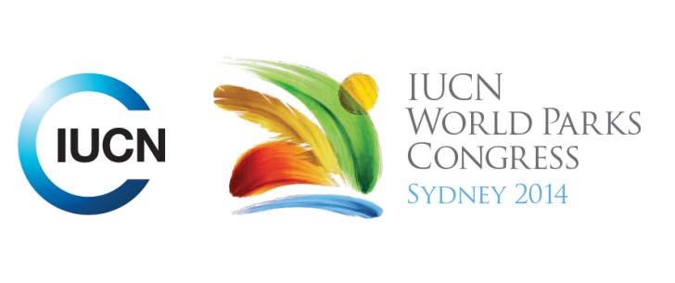

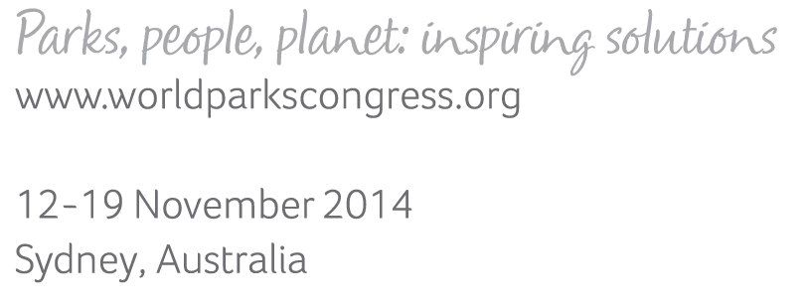

**Please fill-in this word template, save it and email to:**[**WPCReports@iucn.org**](mailto:WPCReports@iucn.org)

|  |  |  |
| --- | --- | --- |
| **Rapporteur’s report on session** | | |
| **Stream Number/WLD/Plenary:--- Stream 4---** | | |
| **Repporteur’s name: --- Mat Wolnicki---** | | |
| **Session ID:---362---** | | **Session Name: --- Water and cities---** |
| ***Summarize the session: Capture 1-3 main insights and findings of this session (including promising opportunities and inspiring solutions).*** | | |
| 1. **---** | Water is a precious resource; 85% of the human population lives in low rainfall environments and there are water shortages in 20% of the planets watersheds and aquifers. The cost of securing water supply is growing, with it being one of the top 3 risks identified at the World Economic Forum 2013. Water shortages are posing serious risks for business activities. Similarly, many people in urban centres don’t know where their tap water comes from. It is important therefore to engage in processes and discussions that will ensure that the real cost of water is captured. The solution is ensuring that both grey and green infrastructure requirements are attributed a real cost. Best available science can be integrated into decision making to select cost-effective conservation and risk mitigation of activities and places (watershed management, soil conservation, agro forestry systems)**---** | |
| 2. **---** | There are two mechanisms for reflecting the true cost of water, water funds and tariffs. Water funds that focus on the conservation of the water shed have been identified as an effective tool for water conservation. The water fund concept is used to link (using hydrological models) industry and commercial water users with critical areas for upstream watershed conservation. There are 44 water fund initiatives across 14 Latin American countries. The other mechanism is to involve the public sector and water regulators to incorporate watershed conservation costs into water use tariffs to recognise ecosystem benefits. This helps ensure the true cost of watershed conservation and reduces water treatment costs. The cost of water should be internalised as it is the true cost, not a tax on an existing resource. There was relevant discussion that the water funds should not only trade-off lowland freshwater ecosystems for upstream conservation, but there needs to be innovative models for freshwater biodiversity conservation downstream, including release of water for overland flows for ecological conservation and involving urban users in water conservation initiatives to make the link between upstream conservation and downstream use **---** | |
| 3. **---** | Multiple water users require innovative governance and funding arrangements to protect green infrastructure, including partnerships with private sector and multilateral donations. The water fund concept showcases how partnerships are created and the benefits of the initiative communicated to emerging initiatives. Collective action is necessary to build synergies and achieve greater impact, involving all value representatives is necessary to achieve a sustainable and resilient outcome. TNC provided a number of examples of how this has taken place in Latin America and these learnings are being applied by TNC in other countries. The success of these programs can be attributed to the ability to engage key partners and good communication with industry. **---** | |

|  |  |  |
| --- | --- | --- |
| Related keywords | | |
| ---Reconciling Development Challenges--- | ---Supporting Human Life--- | ---Enhancing Diversity and Quality of Governance--- |

| **Cross Cutting Themes** |
| --- |
| ***If the session was related to a Cross Cutting Theme, please give some information on what has been discussed.*** |
| **---**Building the capacity of the corporate and public sector to use valuation mechanisms for the protection of green infrastructure **---** |

|  |
| --- |
| Related cross cutting theme |
| ---Capacity Development--- |

| **Recommendations to the IUCN World Parks Congress** | | | |
| --- | --- | --- | --- |
| ***Capture any specific recommendation from this session for the Innovative Approaches documents / Promise of Sydney (along the line of policy changes, capacity development, financing, practice…)*** | | | |
|  | **It was recommended that:** | **Actors** | **Timeline** |
| 1. **---** | Click here to enter text.**---** | **---**Click here to enter text.**---** | **---**Click here to enter text.**---** |
| 2. **---** | Click here to enter text.**---** | **---**Click here to enter text.**---** | **---**Click here to enter text.**---** |
| 3. **---** | Click here to enter text.**---** | **---**Click here to enter text.**---** | **---**Click here to enter text.**---** |

|  |  |  |
| --- | --- | --- |
| Related keywords | | |
| ---Choose an item.--- | ---Choose an item.--- | ---Choose an item.--- |

| **Information for the Communications - Team** |
| --- |
| ***Note any announcements/commitments or people/items of interests to media/communications. Please ensure to include any relevant contact information.*** |
| **---**Click here to enter text.**---** |