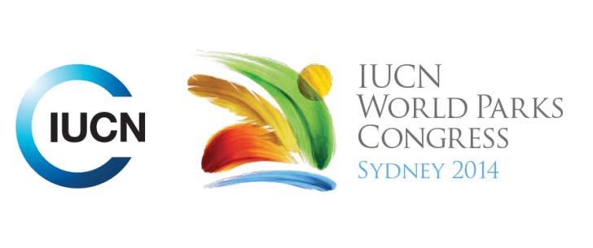

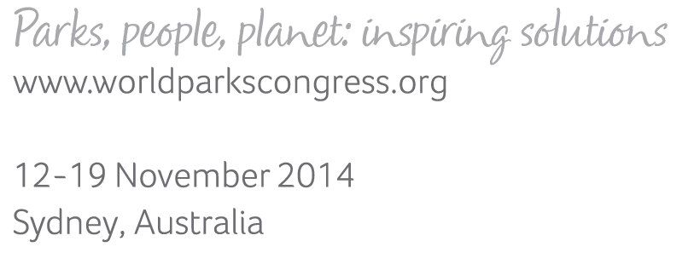

**Please fill-in this word template, save it and email to:**[**WPCReports@iucn.org**](mailto:WPCReports@iucn.org)

|  |  |  |
| --- | --- | --- |
| **Rapporteur’s report on session** | | |
| **Stream Number/WLD/Plenary:--- 3---** | | |
| **Repporteur’s name: --- Barbara Webster---** | | |
| **Session ID:---354---** | | **Session Name: --- Closing the Loop - moving management effectiveness evaluations from reporting to adaptive management---** |
| ***Summarize the session: Capture 1-3 main insights and findings of this session (including promising opportunities and inspiring solutions).*** | | |
| 1. **---** | Closing the loop to integrate the results of Management Effectiveness Evaluation (MEE) in future goals, plans and priorities was the key issue. The need to translate information into management language by being meaningful and relevant was emphasised in the NSW and Victorian State of the Parks example. Their survey requires managers to give results and then provide context and influencing factors, which is often the most useful information. One marine park study looked at seven long-term biological monitoring programs across Australia, and found that they are more likely to be used for qualitative condition assessment and habitat classification than improving management effectiveness. The suggestion was that evaluation needed to be decoupled from formal MEE reporting process to make regular informed changes to management actions. The Great Barrier Reef Marine Park (GBRMP) example showed that despite a comprehensive evaluation process with 31 criteria and 140 indicators, and a good process for closing the loop and translating actions into strategic and operational plans, the key threats to the reef - climate change, coastal development and catchment runoff - had not been addressed because they are socially, biophysically and jurisdictionally complex and broad in scale. **---** | |
| 2. **---** | Presenting information back to managers in easy to use formats is critical. The French Marine Parks have developed a dashboard using selected indicators represented by pictograms for habitats and colours showing condition or conservation status. Dashboards can also make public policies transparent and be used as a tool for communicating with stakeholders. State of the Parks (NSW & Vic) uses on-line data tools to make data easily available for use by park managers. It is accessible at many scales and the hard work of analysis is automated. Traffic light colours are used to summarise results and highlight big issues. Data is reported back to managers in spatial form and can be analysed at multiple scales. The Public Participation GIS project also presented the data in spatial format, using colours to indicate areas of high potential conflict. **---** | |
| 3. **---** | The case studies discussed the use of community knowledge and opinion in management effectiveness evaluation to integrate the views of both park managers and the broader community. State of the Parks trialled community input with feedback from Regional Advisory Committees this year and found strong alignment with the expert management data set, and aims to expand that to a wider public footprint in future. It was noted that people will accept management decisions if they have been involved in the decision-making process through community engagement and that dialogue will lead to better decisions. Participatory GIS tools to engage the community in park management were presented, with evidence that public involvement is beneficial to the MEE process and optimised the outcomes in assessing social and cultural values of public land. Over 35,000 landscape value and land use preference locations were mapped by nearly 2000 study participants, generating social landscape metrics that quantified abundance, richness and diversity of land use, and the potential for conflicts between users. **---** | |

|  |  |  |
| --- | --- | --- |
| Related keywords | | |
| ---Reaching Conservation Goals--- | ---Marine--- | ---World Heritage--- |

| **Cross Cutting Themes** |
| --- |
| ***If the session was related to a Cross Cutting Theme, please give some information on what has been discussed.*** |
| **---**Management effectiveness evaluation (MEE) in Marine Parks. This session considered how management effectiveness evaluations are moving from a reporting focus to capturing best available knowledge to feed back into adaptive management. Case studies from French and Australian Marine Parks demonstrated a range of opportunities and barriers to closing the loop to improving management. One study looked at seven long-term biological monitoring programs across Australia, and found that they are more likely to be used for qualitative condition assessment and habitat classification than improving management effectiveness. The suggestion was that evaluation needed to be decoupled from formal MEE reporting process to make regular informed changes to management actions. The Great Barrier Reef Marine Park (GBRMP) example showed that despite a comprehensive evaluation process with 31 criteria and 140 indicators, and a good process for closing the loop and translating actions into strategic and operational plans, the key threats to the reef - climate change, coastal development and catchment runoff - had not been addressed because they are socially, biophysically and jurisdictionally complex and broad in scale. The French case study created a dashboard using selected indicators represented by pictograms for habitats and colours showing condition or conservation status, which was useful for managers but also, can be used as a tool for communicating with communities. **---** |

|  |
| --- |
| Related cross cutting theme |
| ---Marine--- |

| **Recommendations to the IUCN World Parks Congress** | | | |
| --- | --- | --- | --- |
| ***Capture any specific recommendation from this session for the Innovative Approaches documents / Promise of Sydney (along the line of policy changes, capacity development, financing, practice…)*** | | | |
|  | **It was recommended that:** | **Actors** | **Timeline** |
| 1. **---** | Click here to enter text.**---** | **---**Click here to enter text.**---** | **---**Click here to enter text.**---** |
| 2. **---** | Click here to enter text.**---** | **---**Click here to enter text.**---** | **---**Click here to enter text.**---** |
| 3. **---** | Click here to enter text.**---** | **---**Click here to enter text.**---** | **---**Click here to enter text.**---** |

|  |  |  |
| --- | --- | --- |
| Related keywords | | |
| ---Choose an item.--- | ---Choose an item.--- | ---Choose an item.--- |

| **Information for the Communications - Team** |
| --- |
| ***Note any announcements/commitments or people/items of interests to media/communications. Please ensure to include any relevant contact information.*** |
| **---**Click here to enter text.**---** |