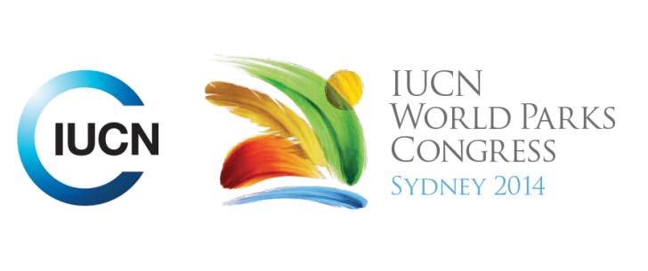



**Please fill-in this word template, save it and email to:**[**WPCReports@iucn.org**](mailto:WPCReports@iucn.org)

|  |  |  |
| --- | --- | --- |
| **Rapporteur’s report on session** | | |
| **Stream Number/WLD/Plenary:--- Responding to Climate Change---** | | |
| **Repporteur’s name: --- Roberto Valera---** | | |
| **Session ID:---305---** | | **Session Name: --- Cultural expressions for maintaining identity and heritage in the face of climate change---** |
| ***Summarize the session: Capture 1-3 main insights and findings of this session (including promising opportunities and inspiring solutions).*** | | |
| 1. **---** | “Climate Change is the greatest ethical threat to the integrity of societies” and it is having a detrimental impact on people and cultures around the world. It is damaging their heritage, customs and traditional practices. Case studies in Iran, Tibet and the Pacific Islands have shown the effect of Climate Change and how it interrupts the relationship between communities and their traditional activities: agriculture, hunting, use of natural resources and even their traditional expressions: artistic, spiritual and holistic. The effect of Climate Change was highlighted based on the impact it has on the level of wildlife, plant species and biodiversity as well as a reduction in water availability and water quality. **---** | |
| 2. **---** | The effect of Climate Change on the traditional activities may lead to the loss of the knowledge that the elders have accumulated as there is no written evidence on historical events to safeguard the historical data and traditions that have been passed on from generation to generation. **---** | |
| 3. **---** | Amongst the different communities there is a strong desire to mitigate Climate Change. Community members and tribal leaders have engaged in seeking alternatives and are committed to implement appropriate mechanisms and measures. There is a willingness to adapt and steps have been taken to promote adaptation, for instance, the introduction of a seasonal calendar to monitor weather patterns, wildlife, plant species and marine life. **---** | |

|  |  |  |
| --- | --- | --- |
| Related keywords | | |
| ---Responding to Climate Change--- | ---Choose an item.--- | ---Choose an item.--- |

| **Cross Cutting Themes** |
| --- |
| ***If the session was related to a Cross Cutting Theme, please give some information on what has been discussed.*** |
| **---**Click here to enter text.**---** |

|  |
| --- |
| Related cross cutting theme |
| ---Choose an item.--- |

| **Recommendations to the IUCN World Parks Congress** | | | |
| --- | --- | --- | --- |
| ***Capture any specific recommendation from this session for the Innovative Approaches documents / Promise of Sydney (along the line of policy changes, capacity development, financing, practice…)*** | | | |
|  | **It was recommended that:** | **Actors** | **Timeline** |
| 1. **---** | Use of historical data and repeat photography as fact gathering tools. To implement an adaptation framework that includes: Focus on groups, connect scientists with community, evaluate traditions and history to increase community knowledge and to pass on the information to future generation. **---** | **---**Click here to enter text.**---** | **---**Click here to enter text.**---** |
| 2. **---** | Click here to enter text.**---** | **---**Click here to enter text.**---** | **---**Click here to enter text.**---** |
| 3. **---** | Click here to enter text.**---** | **---**Click here to enter text.**---** | **---**Click here to enter text.**---** |

|  |  |  |
| --- | --- | --- |
| Related keywords | | |
| ---Choose an item.--- | ---Choose an item.--- | ---Choose an item.--- |

| **Information for the Communications - Team** |
| --- |
| ***Note any announcements/commitments or people/items of interests to media/communications. Please ensure to include any relevant contact information.*** |
| **---**Click here to enter text.**---** |