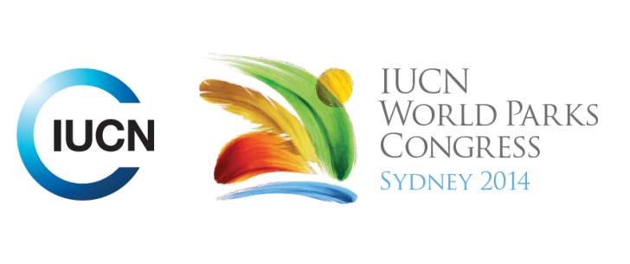

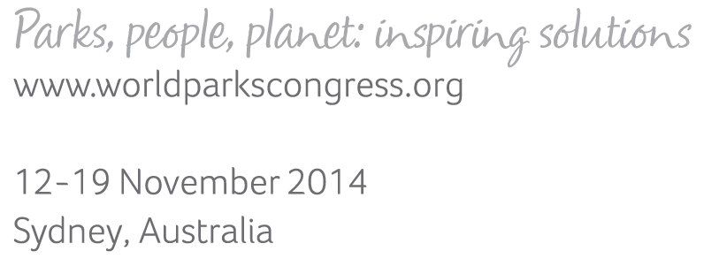

**Please fill-in this word template, save it and email to:**[**WPCReports@iucn.org**](mailto:WPCReports@iucn.org)

|  |  |  |
| --- | --- | --- |
| **Rapporteur’s report on session** | | |
| **Stream Number/WLD/Plenary:--- 2---** | | |
| **Repporteur’s name: --- Jacqui Doyle---** | | |
| **Session ID:---304---** | | **Session Name: --- Restoring natural systems to provide resilience to climate change ---** |
| ***Summarize the session: Capture 1-3 main insights and findings of this session (including promising opportunities and inspiring solutions).*** | | |
| 1. **---** | Case studies and examples of ecological restoration were presented from Kenya, Mexico, Colombia, Chile, Vietnam, Nepal, Lesotho and South Africa. Ecological restoration was described as an engaging and inclusive process, with protected areas increasingly being seen as providing natural solutions for climate change adaptation and for increasing local communities’ capacity to respond to this challenge. These restoration activities are resulting in a broad range of biodiversity outcomes, as well as supporting livelihoods, providing more secure water sources, reducing conflict, improving park visitor experiences and promoting and increasing awareness of climate change issues. **---** | |
| 2. **---** | In Vietnam two case studies were presented in the Kien Giang Biosphere Reserve issues and the U Minh Thuong National Park. Issues/threats include large scale conversion to rice and agriculture, inappropriate management, loss of mangroves to large scale aquaculture and changes to hydrology due to canal development. In Kien Giang Melaleuca poles are being used for fences in mangrove restoration, wave energy reduced by 63%, fences retain mud and assist in seedling survival, assist natural recruitment, enhance marine biodiversity. Fencing efforts are being scaled up nationally in Vietnam. In U Minh Thuong, an improved water management plan is being applied since 2010. Water releases are leading to the recovery of wetland hydrology and wildlife habitat (especially birds). In Maloti Drakensberg (Lesotho and South Africa) – the objectives of the restoration activities are to rehabilitate the wetlands to assist with building climate change resilience, strengthen international collaboration and improving social cohesion. Outcomes sought from this work are to improve ecosystem health, improved livestock health, improved vegetation cover, less runoff and groundwater replenishment. The project is also providing training and work opportunities and promoting awareness of local communities. **---** | |
| 3. **---** | The Panachase Protected Forest area in Nepal is rich in natural and socio-cultural resources, but also highly vulnerable to climate change. Plantation is being promoted to adapt and mitigate to climate change impacts. Despite of high investment, plantation performance has traditionally been poor (due to, for instance, poor manage, species selection and technical support). The presentation explored opportunities to improve performance including by providing incentives to achieve the goal of economic growth and environmental sustainability in partnership with public, private and community institutions. Restoration payments were seen to be cost effective, output orientated and providing improved environmental benefits. In Kenya restoration activities in protected areas have included rehabilitation and restoration of wetlands, forests, mangroves and savannahs, enhancement of water storage capacity for wildlife and communities, connecting different ecosystems and habitats to enable populations and biodiversity access. In addition to improving biodiversity outcomes, these efforts have improved visitor experiences, improved education and awareness and lowered human wildlife conflict. **---** | |

|  |  |  |
| --- | --- | --- |
| Related keywords | | |
| ---Responding to Climate Change--- | ---Choose an item.--- | ---Choose an item.--- |

| **Cross Cutting Themes** |
| --- |
| ***If the session was related to a Cross Cutting Theme, please give some information on what has been discussed.*** |
| **---**Click here to enter text.**---** |

|  |
| --- |
| Related cross cutting theme |
| ---Choose an item.--- |

| **Recommendations to the IUCN World Parks Congress** | | | |
| --- | --- | --- | --- |
| ***Capture any specific recommendation from this session for the Innovative Approaches documents / Promise of Sydney (along the line of policy changes, capacity development, financing, practice…)*** | | | |
|  | **It was recommended that:** | **Actors** | **Timeline** |
| 1. **---** | Click here to enter text.**---** | **---**Click here to enter text.**---** | **---**Click here to enter text.**---** |
| 2. **---** | Click here to enter text.**---** | **---**Click here to enter text.**---** | **---**Click here to enter text.**---** |
| 3. **---** | Click here to enter text.**---** | **---**Click here to enter text.**---** | **---**Click here to enter text.**---** |

|  |  |  |
| --- | --- | --- |
| Related keywords | | |
| ---Choose an item.--- | ---Choose an item.--- | ---Choose an item.--- |

| **Information for the Communications - Team** |
| --- |
| ***Note any announcements/commitments or people/items of interests to media/communications. Please ensure to include any relevant contact information.*** |
| **---**Click here to enter text.**---** |