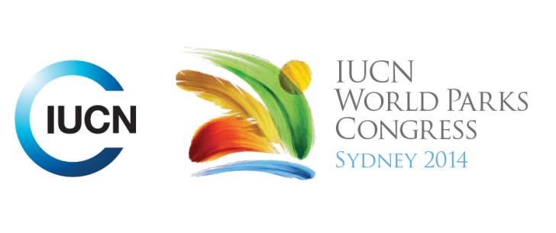

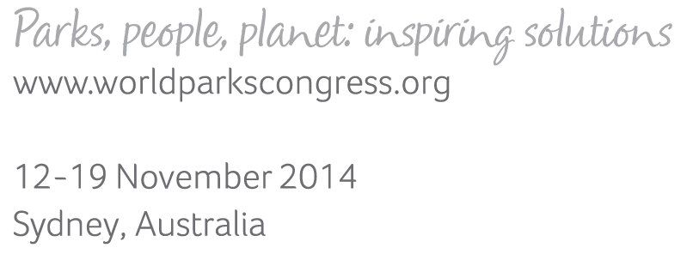

**Please fill-in this word template, save it and email to:**[**WPCReports@iucn.org**](mailto:WPCReports@iucn.org)

|  |  |  |
| --- | --- | --- |
| **Rapporteur’s report on session** | | |
| **Stream Number/WLD/Plenary:---** Click here to enter text.**---** | | |
| **Repporteur’s name: --- Melissa Marin---** | | |
| **Session ID:---301---** | | **Session Name: --- Assessing resource and cultural vulnerability to climate change---** |
| ***Summarize the session: Capture 1-3 main insights and findings of this session (including promising opportunities and inspiring solutions).*** | | |
| 1. **---** | The main objective of this session is to present different climate change vulnerability analysis tools, approaches, frameworks and methodologies that includes links among biodiversity, cultural and economic sceneries, and considering exposure, sensitivity and adaptive capacity. This trough specific studies cases developed in Madagascar, Australia, Tanzania, Kenya, Fiji islands and others. These tools were Climate Change Vulnerability Assessment System; different approaches to measure species vulnerabilities such as correlative, mechanistic and trait –bassed approaches; Reefs to Ridges conservation approach; Environmental Niche Modelling with Maximum Entrophy; Modelled Species Distribution with ZONATION, and others. Some of the results were the identification of next steps needed for advancing each metholodogy forward and the identification of management options to enhance resilience**---** | |
| 2. **---** | Climate change is a serious threat for all ecosystems and specially for costal and marine habitats (such as coral reefs) and understanding the vulnerability of species, ecosystems, ecological processes and people to the different forms of climate change within and beyond parks is a challenging exercise. **---** | |
| 3. **---** | It is highly urgent to develop a monitoring system to identify changes in social ecological vulnerability of tropical coastal communities. One of the main efforts on this is the Dashboard Framework that includes indicators such as pressure, state, social and ecological vulnerability, response and benefits). **---** | |

|  |  |  |
| --- | --- | --- |
| Related keywords | | |
| ---Responding to Climate Change--- | ---Choose an item.--- | ---Choose an item.--- |

| **Cross Cutting Themes** |
| --- |
| ***If the session was related to a Cross Cutting Theme, please give some information on what has been discussed.*** |
| **---**Click here to enter text.**---** |

|  |
| --- |
| Related cross cutting theme |
| ---Choose an item.--- |

| **Recommendations to the IUCN World Parks Congress** | | | |
| --- | --- | --- | --- |
| ***Capture any specific recommendation from this session for the Innovative Approaches documents / Promise of Sydney (along the line of policy changes, capacity development, financing, practice…)*** | | | |
|  | **It was recommended that:** | **Actors** | **Timeline** |
| 1. **---** | How ecosystem management can reduce climate changes treats? The most important think is including traditional management approaches and finding what is the people willing to do.**---** | **---**Click here to enter text.**---** | **---**Click here to enter text.**---** |
| 2. **---** | **------** | **---**Click here to enter text.**---** | **---**Click here to enter text.**---** |
| 3. **---** | Click here to enter text.**---** | **---**Click here to enter text.**---** | **---**Click here to enter text.**---** |

|  |  |  |
| --- | --- | --- |
| Related keywords | | |
| ---Responding to Climate Change--- | ---Choose an item.--- | ---Choose an item.--- |

| **Information for the Communications - Team** |
| --- |
| ***Note any announcements/commitments or people/items of interests to media/communications. Please ensure to include any relevant contact information.*** |
| **---UICN SCC Best Guidelines for assessing species vulnerability ---** |