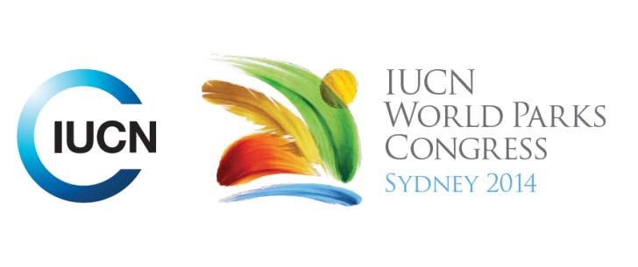



**Please fill-in this word template, save it and email to:**[**WPCReports@iucn.org**](mailto:WPCReports@iucn.org)

|  |  |  |
| --- | --- | --- |
| **Rapporteur’s report on session** | | |
| **Stream Number/WLD/Plenary:--- 2---** | | |
| **Repporteur’s name: --- Jacqui Doyle---** | | |
| **Session ID:---291---** | | **Session Name: --- Promise of protected areas as natural solutions ---** |
| ***Summarize the session: Capture 1-3 main insights and findings of this session (including promising opportunities and inspiring solutions).*** | | |
| 1. **---** | Protected areas present many opportunities for addressing climate change, including the opportunity to inspire a new generation. Rather than presenting stories of doom and gloom, which do not inspire, protected areas bring stories of hope. There are opportunities to use ‘charismatic’ species that occur in protected areas that are migrating as a result of climate change. By explaining that these species need a corridor in order to move, this can be an invaluable way to educate people about the impacts of climate change. It is important to express ourselves much better, and to translate our concerns into political language. **---** | |
| 2. **---** | From experiences in Peru, it was recommended that the role of finances should be expanded beyond protected areas. It was also suggested that we take an ecosystem services approach to national and international efforts for climate change emission reductions. A suggestion for a ‘National ecological services commitment’ was made, which would including payments to forest rich countries for ecosystem services. It was recognised that many organisations are doing good work on protected areas but that these efforts could be more effective if areas of common ground were identified **---** | |
| 3. **---** | In Queensland, Australia, the protected area acquisition strategy is focused on refugia areas (stable, accessible to species and facilitated persistence in the landscape) and using science to develop highly resilient and connected protected areas.**---** | |

|  |  |  |
| --- | --- | --- |
| Related keywords | | |
| ---Responding to Climate Change--- | ---Choose an item.--- | ---Choose an item.--- |

| **Cross Cutting Themes** |
| --- |
| ***If the session was related to a Cross Cutting Theme, please give some information on what has been discussed.*** |
| **---**Click here to enter text.**---** |

|  |
| --- |
| Related cross cutting theme |
| ---Choose an item.--- |

| **Recommendations to the IUCN World Parks Congress** | | | |
| --- | --- | --- | --- |
| ***Capture any specific recommendation from this session for the Innovative Approaches documents / Promise of Sydney (along the line of policy changes, capacity development, financing, practice…)*** | | | |
|  | **It was recommended that:** | **Actors** | **Timeline** |
| 1. **---** | A suggestion for a ‘National ecological services commitment’ was made, which would including payments to forest rich countries for ecosystem services, which would expand the impact of green carbon funds and promote the importance of climate.**---** | **---**Click here to enter text.**---** | **---**Click here to enter text.**---** |
| 2. **---** | It was recommended that the role of finances should be expanded beyond protected areas. .**---** | **---**Click here to enter text.**---** | **---**Click here to enter text.**---** |
| 3. **---** | It was suggested that we take an ecosystem services approach to national and international efforts for climate change emission reductions.**---** | **---**Click here to enter text.**---** | **---**Click here to enter text.**---** |

|  |  |  |
| --- | --- | --- |
| Related keywords | | |
| ---Choose an item.--- | ---Choose an item.--- | ---Choose an item.--- |

| **Information for the Communications - Team** |
| --- |
| ***Note any announcements/commitments or people/items of interests to media/communications. Please ensure to include any relevant contact information.*** |
| **---**Click here to enter text.**---** |