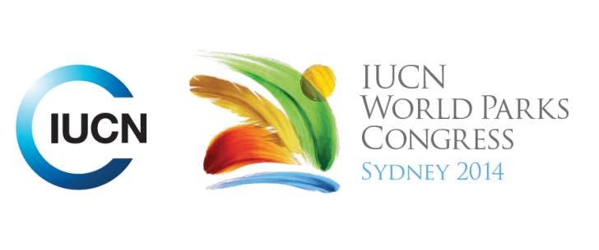

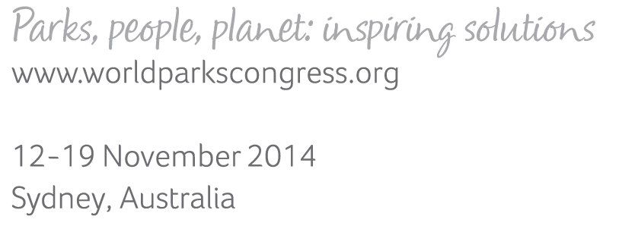

**Please fill-in this word template, save it and email to:**[**WPCReports@iucn.org**](mailto:WPCReports@iucn.org)

|  |  |  |
| --- | --- | --- |
| **Rapporteur’s report on session** | | |
| **Stream Number/WLD/Plenary:--- Stream 1---** | | |
| **Repporteur’s name: --- Kate Robinson---** | | |
| **Session ID:---235---** | | **Session Name: --- Innovative Protected Area Management Part 3---** |
| ***Summarize the session: Capture 1-3 main insights and findings of this session (including inspiring stories, promising opportunities and innovative solutions).*** | | |
| 1. **---** | Innovation can happen at many different scales and levels. Innovation can happen globally/in a park/at species level/locally. It is not just the domain of leadership. This session demonstrated this via examination of several case studies: Amazon, Great Barrier Reef, Caribbean, Galapagos and Tasmania (5 Rivers Reserve). For example in the Galapagos, zoning plans came last in developing management plans (ie other evaluation and plan development was prioritised to have a firm knowledge base before zoning was developed); in creating the 5 Rivers Nature Reserve, one third of the budget became an endowment fund to allow for long term ecological management. All examples found local/community engagement to be crucial to their success. However innovation should be assessed in some manner so as to look at it in the context of the big picture.**---** | |
| 2. **---** | Trends in protected areas include many threats to protected areas such as: park management agencies being established as entrepreneurs to fund protected areas, PADD and the use of non-permanent staff. However another trend of employing staff without degrees then requires internal education which provides an opportunity for ‘indoctrination’ of staff and development to create a strong workforce. Good communication should be used to inform the public and stakeholders before attempting to influence them. This then requires appropriate monitoring and reporting, needing to be truthful about failures as well as successes.**---** | |
| 3. **---** | Case study: Virua National Park, BrazilianAmazon shows that research is not a luxury because it can bring great benefits to protected areas. Under budget constraints, a strategy was developed to perform research within the park. Engaging and employing the local community was a fundamental requirement of doing research. The results were enhanced protection with increased vigilance for illegal activities (people were in the park), increased attractiveness to ecotourism (showcasing enormous biodiversity), engaging local people with conservation goals (increased jobs, revenue, and education). Other case studies presented included the use of risk based planning on the Great Barrier Reef and the use of a Natural Heritage Integrated tool in developing management planning for the Galapagos. **---** | |

|  |  |  |
| --- | --- | --- |
| Related keywords | | |
| ---Reaching Conservation Goals--- | ---Capacity Development--- | ---World Heritage--- |

| **Cross Cutting Themes** |
| --- |
| ***If the session was related to a Cross Cutting Theme, please give some information on what has been discussed.*** |
| **---**Click here to enter text.**---** |

|  |
| --- |
| Related cross cutting theme |
| ---Choose an item.--- |

| **Recommendations to the IUCN World Parks Congress** | | | |
| --- | --- | --- | --- |
| ***Capture any specific recommendation from this session for the Innovative Approaches documents / Promise of Sydney (along the line of policy changes, capacity development, financing, practice…)*** | | | |
|  | **It was recommended that:** | **Actors** | **Timeline** |
| 1. **---** | Capacity development should focus on the purpose of a protected area and the needs of the protected management to deliver outcomes directly related to the purpose of the protected area. This approach has the potential to enhance knowledge and change attitudes and capacities for application beyond a particular project.**---** | **---**Click here to enter text.**---** | **---**Click here to enter text.**---** |
| 2. **---** | Use a compliance risk management plan (risk based planning) and work in partnership with regulatory agencies to manage protected areas and get the best outcome from available resources, for example as is used on the Great Barrier Reef Australia.**---** | **---**Click here to enter text.**---** | **---**Click here to enter text.**---** |
| 3. **---** | Fund research in protected areas as means to increase vigilance for illegal activities in protected areas, increase ecotourism, and engage local people with conservation goals. Research is not a luxury, community engagement is crucial**---** | **---**Click here to enter text.**---** | **---**Click here to enter text.**---** |

|  |  |  |
| --- | --- | --- |
| Related keywords | | |
| ---Capacity Development--- | ---World Heritage--- | ---Choose an item.--- |

| **Information for the Communications - Team** |
| --- |
| ***Note any announcements/commitments or people/items of interests to media/communications. Please ensure to include any relevant contact information.*** |
| **---Antonio Lisboa, Geographer M.Sc. presented ‘Megadiversity in Virua National Park’ about funding research requiring partnership with local communities in the Amazon. Has been hugely successful.---** |