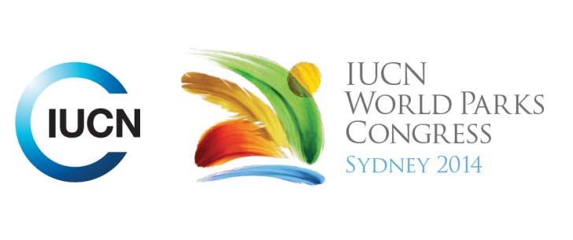



**Please fill-in this word template, save it and email to:**[**WPCReports@iucn.org**](mailto:WPCReports@iucn.org)

|  |  |  |
| --- | --- | --- |
| **Rapporteur’s report on session** | | |
| **Stream Number/WLD/Plenary:---Plenary---** | | |
| **Repporteur’s name: ---Camille and Kate ---** | | |
| **Session ID:---211---** | | **Session Name:---Opening Plenary---** |
| ***Summarize the session: Capture 1-3 main insights and findings of this session (including promising opportunities and inspiring solutions).*** | | |
| 1.**---** | Speakers acknowledged many achievements and challenges, particularly since Durban: - - For the past 50 years, about 192 countries have contributed to protecting about 32 millions Km2 of PA which is the equivalent of Africa; - Climate Change Agreement between China and USA; - Countries of Pacific Islands have secured about 40 million Km2 of Marine PA using “boule” as a working model; -Pacific islands leaders concerns included that serious action should be taken against climate change, otherwise countries of pacific islands will suffer a lot; there is hope (95%) that a commitment will come out from Paris next year on Climate change.- The world has suffered from financial crisis, hence AP. Many speakers paid tribute to IPs custodianship of environment**---** | |
| 2.**---** | It was noted that we are one generation amongst a series of generations. PAs are beginning to be appropriately valued in a financial/economic sense. People are integral to PA which contributes to our overall understanding of the Planet **---** | |
| 3.**---** | PAs are not simply in a world of islands, they are Allied with men. We must go beyond solely conservation to include economic and social aspects. Countries should consider conservation not as a burden but as a service provider and worthy of investment.**---** | |

|  |  |  |
| --- | --- | --- |
| Related keywords | | |
| ---Marine--- | ---Reaching Conservation Goals--- | ---Supporting Human Life--- |

| **Cross Cutting Themes** |
| --- |
| ***If the session was related to a Cross Cutting Theme, please give some information on what has been discussed.*** |
| **---**Click here to enter text.**---** |

|  |
| --- |
| Related cross cutting theme |
| ---Choose an item.--- |

| **Recommendations to the IUCN World Parks Congress** | | | |
| --- | --- | --- | --- |
| ***Capture any specific recommendation from this session for the Innovative Approaches documents / Promise of Sydney (along the line of policy changes, capacity development, financing, practice…)*** | | | |
|  | **It was recommended that:** | **Actors** | **Timeline** |
| 1.**---** | It is important to engage youth especially as increasing urbanisation contribute to disconnect between youth and nature. We should share knowledge and learn from them, as we borrowed land from them and we have the duty to transfer it back safe**---** | **---**Click here to enter text.**---** | **---**Click here to enter text.**---** |
| 2.**---** | There are a complex issues that can’t be solved immediately, but instead will require cooperation and collaboration **---** | **---**Click here to enter text.**---** | **---**Click here to enter text.**---** |
| 3.**---** | We need to consider issues across boundaries/border and at landscape scale**---** | **---**Click here to enter text.**---** | **---**Click here to enter text.**---** |

|  |  |  |
| --- | --- | --- |
| Related keywords | | |
| ---Choose an item.--- | ---Choose an item.--- | ---Choose an item.--- |

| **Information for the Communications - Team** |
| --- |
| ***Note any announcements/commitments or people/items of interests to media/communications. Please ensure to include any relevant contact information.*** |
| **---**Click here to enter text.**---** |