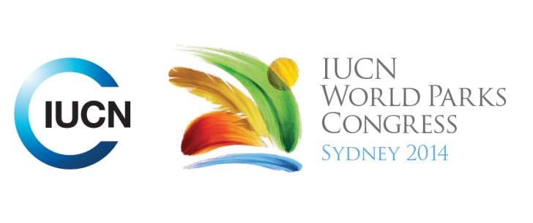

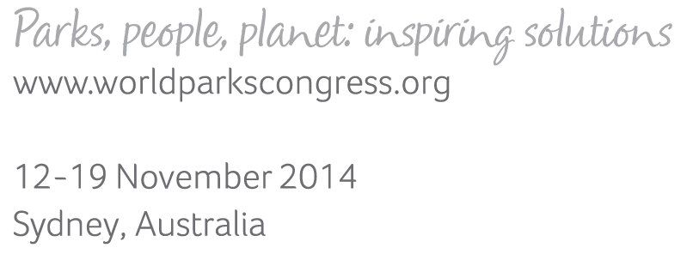

**Please fill-in this word template, save it and email to:**[**WPCReports@iucn.org**](mailto:WPCReports@iucn.org)

|  |  |  |
| --- | --- | --- |
| **Rapporteur’s report on session** | | |
| **Stream Number/WLD/Plenary:--- Plenary 3---** | | |
| **Repporteur’s name: --- Camille and Kate---** | | |
| **Session ID:---164---** | | **Session Name: --- Closing Plenary 3---** |
| ***Summarize the session: Capture 1-3 main insights and findings of this session (including promising opportunities and inspiring solutions).*** | | |
| 1. **---** | Mainstream protected areas into the core of economic and sectoral development, although protected areas are not going to be enough. To embed protected areas into the wider development agenda, it needs to be in a language that is politically relevant. Learn from experiences that can be scaled up and change the way we do business. Landuse planning should occur at landscape level; therefore tools are required by governments to allow strategic planning at a landscape scale. Protected areas should be integrated into key sectoral plans. Look at cumulative impacts. It was noted many of the promises of Durban were not delivered (and were not drafted in a way to provide tangible solutions). Hence capacity development CCT is developing a roadmap (to acknowledge capacity development as essential means for achieving conservation goals).**---** | |
| 2. **---** | Protected areas should be appropriately valued in economic terms via green accounting/ Natural capital accounting. Make protected areas part of the economy (integrate development and human well being). Integrating protected areas values into economic procedures from accounting ultimately into standard national accounting on a global scale. Connect to better value ecosystem services. Ensure sufficient safeguards so we can better understand full costs and benefits and understand the tradeoffs and risks. Major challenge: when habitat is lost for agriculture or housing, we see development, but when we invest in protected areas we don’t see it as part of development and that needs to change. Need more efficient mobilization of resources in order to achieve targets. The financial gap is big (only $11 billion instead of the $33billion required), but that is a tiny amount in global GDP terms so should be easy to address.**---** | |
| 3. **---** | Integrating traditional knowledge with western science. Both should contribute to park management decisions. Knowledge: Better data for better decisions. Modernity must learn about connectivity. Understand connections. Recognise and respect culture. Much has been achieve since Durban – 2007 recognition of indigenous people was a fundamental achievement. But not enough has been done to put indigenous people at the centre of protected areas management. Indigenous people are not yet recognized as equal partners. International recognition has not been implemented at the national levels. IUCN has been part of the problem (colonial past) and needs to be part of the solution /change /transformation /dialogue. Process of moving from fragmentation to integration which requires an honest reassessment of historical injustices re conservation. Look also at how to involve youth, to encourage youth participation in protected area management. Make dialogue fair and inclusive.**---** | |

|  |  |  |
| --- | --- | --- |
| Related keywords | | |
| ---Reconciling Development Challenges--- | ---Respecting Indigenous and Traditional Knowledge and Culture--- | ---New Social Compact--- |

| **Cross Cutting Themes** |
| --- |
| ***If the session was related to a Cross Cutting Theme, please give some information on what has been discussed.*** |
| **---**. It was noted many of the promises of Durban were not delivered (and were not drafted in a way to provide tangible solutions). Hence capacity development CCT is developing a roadmap (to acknowledge capacity development as essential means for achieving conservation goals). Recognise protected area managers and workers as professionals, particularly with respect to indigenous people who know the most about specific land. Capacity development must be integral to all protected area management and protected area systems and to national and international conservation development and funding priorities.**---** |

|  |
| --- |
| Related cross cutting theme |
| ---Capacity Development--- |

| **Recommendations to the IUCN World Parks Congress** | | | |
| --- | --- | --- | --- |
| ***Capture any specific recommendation from this session for the Innovative Approaches documents / Promise of Sydney (along the line of policy changes, capacity development, financing, practice…)*** | | | |
|  | **It was recommended that:** | **Actors** | **Timeline** |
| 1. **---** | IP members of IUCN should work towards convening a dialogue towards a better preparation for the next IUCN congress 2015. IUCN should provide support for such a dialogue**---** | **---**IPs and IUCN**---** | **---**Click here to enter text.**---** |
| 2. **---** | Click here to enter text.**---** | **---**Click here to enter text.**---** | **---**Click here to enter text.**---** |
| 3. **---** | Click here to enter text.**---** | **---**Click here to enter text.**---** | **---**Click here to enter text.**---** |

|  |  |  |
| --- | --- | --- |
| Related keywords | | |
| ---Choose an item.--- | ---Choose an item.--- | ---Choose an item.--- |

| **Information for the Communications - Team** |
| --- |
| ***Note any announcements/commitments or people/items of interests to media/communications. Please ensure to include any relevant contact information.*** |
| **---**Click here to enter text.**---** |