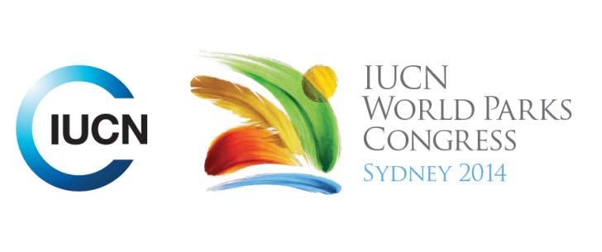

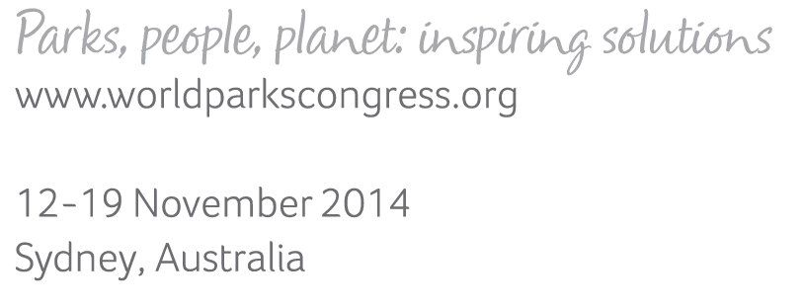

**Please fill-in this word template, save it and email to:**[**WPCReports@iucn.org**](mailto:WPCReports@iucn.org)

|  |  |  |
| --- | --- | --- |
| **Rapporteur’s report on session** | | |
| **Stream Number/WLD/Plenary:--- congress---** | | |
| **Repporteur’s name: --- Sandra Schuster---** | | |
| **Session ID:---1226---** | | **Session Name: --- Landscape approaches to development and conservation - the mitigation hierarchy and biodiversity offsetsa---** |
| ***Summarize the session: Capture 1-3 main insights and findings of this session (including promising opportunities and inspiring solutions).*** | | |
| 1. **---** | Measuring changing pressures within protected areas: Global pressures on biodiversity are not well mapped on a global scale, hence decision making is hindered. Things that are affecting nature are captures by a human pressure index for land (road, electricity, human population density) and sea, was shown and the global view of changes in pressure across the planet over the last two decades. 209,000 world wide protected areas exist and they cover about 15% of the terrestrial world. Protected areas are the most important conservation tool, they are a target of huge investments globally and their numbers are still growing. Pressure mapping is a new way assess protected area effectiveness. It can include changes in pressures can be mapped, covers Land and Sea, can be combined with protected area data, Shows variation globally, Might be used for decision making, Need to split pressures down, and make the idea more operational.**---** | |
| 2. **---** | The key steps in integrating biodiversity with an Environmental and Social Impact Assessment were introduced. These include Risk screening for important biodiversity values, Assessment of important biodiversity values, Qualitative impact assessment and mitigation plan, Quantitative impact assessment and mitigation plan, and Integration with project Environmental and Social Management System. Landcape needs to be considered at each step. Examples of Unconventional oil and gas in North American grassland, Gas pipelines in south-east Asia, Oil and gas in East Africa, railway in W Africa, East Asia-Australia Flyway.The landscape context should ALWAYS be considered in biodiversity impact assessment and application of the mitigation hierarchy. The appropriate scale will vary with project stage, project type and potential impacts, ecology of each biodiversity feature. Issues to consider include connectivity, ecological dependencies, movements and migration, boundaries of management units. It’s essential to consider indirect impacts. It’s essential to consider cumulative impacts. Applying a landscape approach appropriately requires considerable ecological, engineering and socio-economic expertise. This is a developing area of best practice: better guidance and examples are needed! Another presentation focused on Integrated Sustainable Landuse Planning being essential. Things to remember are that there are many land uses and different stakeholders and they have a good representation of all these overlaying ecological and biodiversity data sets. Explore opportunities for alternative land uses or appropriate landuses given what we understand from key outputs of this assessment. Explore areas of conflict and trade-offs where multiple landuses/options occur.The applying the mitigation hierarchy on a grand scale was presented. Impacts can be classified as Point source (Mining footprints, Industrial plant), Linear (Infrastructure), or as never a point source (Primary impacts, Secondary and cumulative impacts). The mitigation hierarchy can be defined as Avoid, Reduce, Restore, Offset and Contribute. What has been lacking to date is a lack of guidance and framework on landscape assessment. A series of objectives were rationalised into four key components for the LLA: a spatial conservation assessment, ecological (non-spatial) assessment and economic assessment supported by a programme of communications and outreach activities. **---** | |
| 3. **---** | . NSW Biodiversity Offsets Policy for Major Projects on private land in New South Wales was presented. The policy applies to large scale and important developments such as railways, highways, mines and hospitals, which are of key social and economic importance for NSW and therefore high priority. A key objective of the policy is to use biodiversity offsets to achieve real benefits for the environment. Aichi targets can only be met if we include private land. Aichi target 11: 17% by 2020, 9% of NSW in national parks and reserves. Predict improvements to biodiversity likely to be achieved through protecting and managing a site. Biobanking agreements provide government with 5 key elements that are an important component of an offset scheme. Because the biobank site is assessed according to a standard method, the biodiversity values are measured and recorded. This information informs the management plan, which sets out the management actions that required to be undertaken for improving and maintaining the site. The landowner enters an agreement with the Minister for the Environment to undertake these management actions – this allows them to generate biodiversity credits that can be bought by developers. The active management is funded by annual payments to landowners to manage their land for biodiversity. Landholders also have the flexibility to establish a biobank site on any portion of their property and undertake other activities on the remainder. Clear governance arrangements including reporting, audit and enforcement. Developed a policy that is generating a genuine financial incentive to conserve important biodiversity on private land. This is a policy instrument with potential to help meet our obligations under the Convention on Biodiversity. Starts to overcome the issue of biodiversity being treated as an externality in the course of global development – it is becoming a financially valuable part of the landscape.**---** | |

|  |  |  |
| --- | --- | --- |
| Related keywords | | |
| ---Reaching Conservation Goals--- | ---Enhancing Diversity and Quality of Governance--- | ---Choose an item.--- |

| **Cross Cutting Themes** |
| --- |
| ***If the session was related to a Cross Cutting Theme, please give some information on what has been discussed.*** |
| **---**Click here to enter text.**---** |

|  |
| --- |
| Related cross cutting theme |
| ---Choose an item.--- |

| **Recommendations to the IUCN World Parks Congress** | | | |
| --- | --- | --- | --- |
| ***Capture any specific recommendation from this session for the Innovative Approaches documents / Promise of Sydney (along the line of policy changes, capacity development, financing, practice…)*** | | | |
|  | **It was recommended that:** | **Actors** | **Timeline** |
| 1. **---** | **---** | **---**Click here to enter text.**---** | **---**Click here to enter text.**---** |
| 2. **---** | Click here to enter text.**---** | **---**Click here to enter text.**---** | **---**Click here to enter text.**---** |
| 3. **---** | Click here to enter text.**---** | **---**Click here to enter text.**---** | **---**Click here to enter text.**---** |

|  |  |  |
| --- | --- | --- |
| Related keywords | | |
| ---Choose an item.--- | ---Choose an item.--- | ---Choose an item.--- |

| **Information for the Communications - Team** |
| --- |
| ***Note any announcements/commitments or people/items of interests to media/communications. Please ensure to include any relevant contact information.*** |
| **---**Click here to enter text.**---** |