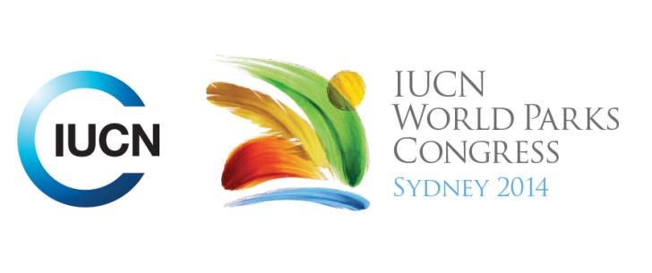

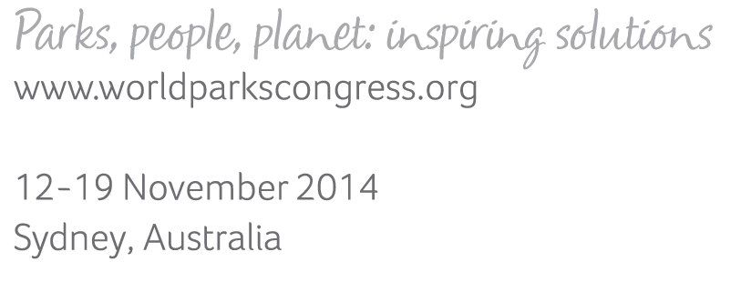

**Please fill-in this word template, save it and email to:**[**WPCReports@iucn.org**](mailto:WPCReports@iucn.org)

|  |  |  |
| --- | --- | --- |
| **Rapporteur’s report on session** | | |
| **Stream Number/WLD/Plenary:--- Stream 4---** | | |
| **Repporteur’s name: --- Anshuman Saikia---** | | |
| **Session ID:---1036---** | | **Session Name: --- Business input into the Promise of Sydney---** |
| ***Summarize the session: Capture 1-3 main insights and findings of this session (including promising opportunities and inspiring solutions).*** | | |
| 1. **---** | A key insight was that business expressed concern that the emerging call for having a blanket 'no go area' policy in PAs and KBAs was not very constructive. Instead there should be better guidance to government on the no go areas as well as look at the no go areas from a landscape and seascape context identifying multiple land uses and determining those areas that need to be strictly protected. The other suggestion was on using the mitigation hierarchy as opposed to blanket no go areas policy. However it was clarified that World Heritage Sites are 'no go areas' and currently IUCN is in the process of trying to get other businesses on board over and above those it currently engages with to understand this regulation. **---** | |
| 2. **---** | The second insight was on the need to engage with companies over and beyond the extractive industries sector including those in the technology space that can support improved management of PAs. The example of the partnership with Google was pointed out as a best practice case. In addition, it was mentioned that there is a need to work with businesses on developing business cases for conservation to demonstrate to them how by supporting conservation they will improve their profitability and other financial health indicators. As expressed by a business representative, businesses can be alternate sources of data and information and contribute data towards achieving conservation goals. **---** | |
| 3. **---** | The third insight was on the need for businesses to proactively incorporate shared values which implies both development/economic values as well as conservation values. It was recognised that some businesses have clearly integrated these shared values into their corporate philosophy and business practices however there are many others that have not done so and whose actions have adverse effects on PAs. It was identified that natural capital accounting would be a good tool to enable businesses to understand the importance of the conservation values This would also imply business recognising indigenous and community conserved areas as well as rights of indigenous people. **---** | |

|  |  |  |
| --- | --- | --- |
| Related keywords | | |
| ---Reconciling Development Challenges--- | ---Reaching Conservation Goals--- | ---Respecting Indigenous and Traditional Knowledge and Culture--- |

| **Cross Cutting Themes** |
| --- |
| ***If the session was related to a Cross Cutting Theme, please give some information on what has been discussed.*** |
| **---**There were considerable discussions on World Heritage sites being 'no go areas'**---** |

|  |
| --- |
| Related cross cutting theme |
| ---World Heritage--- |

| **Recommendations to the IUCN World Parks Congress** | | | |
| --- | --- | --- | --- |
| ***Capture any specific recommendation from this session for the Innovative Approaches documents / Promise of Sydney (along the line of policy changes, capacity development, financing, practice…)*** | | | |
|  | **It was recommended that:** | **Actors** | **Timeline** |
| 1. **---** | Click here to enter text.**---** | **---**Click here to enter text.**---** | **---**Click here to enter text.**---** |
| 2. **---** | Click here to enter text.**---** | **---**Click here to enter text.**---** | **---**Click here to enter text.**---** |
| 3. **---** | Click here to enter text.**---** | **---**Click here to enter text.**---** | **---**Click here to enter text.**---** |

|  |  |  |
| --- | --- | --- |
| Related keywords | | |
| ---Choose an item.--- | ---Choose an item.--- | ---Choose an item.--- |

| **Information for the Communications - Team** |
| --- |
| ***Note any announcements/commitments or people/items of interests to media/communications. Please ensure to include any relevant contact information.*** |
| **---**Click here to enter text.**---** |